**Detailed Business Specific Requirements:-**

**Theme**: Existing IT system for internal agencies of MoJS

**Applications**: WIMS expansion-WRIS

**Use Cases:-** Inter Basin Transfer Link-**WRIS-SSA-06**

**Other linked Use Case :-** Identification Of nearest reliable source (WT-UC-02), Optimal Route identification for existing network (WT-UC-03), Optimal Route identification for new network (WT-UC-04), Inter basin transfer (WT-UC-05), Mapping Of minor irrigation tanks schemes (WT-UC-06), Inflow To the schemes (WT-UC-07), Govt. Schemes And Policy Interventions (WI-UC-08), Water Availability (WB-UC-01), Water Demand (WB-UC-02), Water Balance (WB-UC-03), Additional Water harvesting structures (WB-UC-04), Additional Schemes (WB-UC-05), importing from surplus units (WB-UC-08), Rationalizing demand (WB-UC-07), Future need (WB-UC-08),Water Security Plans(WSP) (WB-UC-08), Water Audit (WB-UC-10), Plans For interlinking (WFP-UC-01), Inter Basin transfer of water (WFP-UC-02), Virtual water (WFP-UC-03), Virtual Water transfer (WFP-UC-04), Virtual water saving (WFP-UC-05), Type of water foot print (WFP-UC-06), Features of water foot print (WFP- UC-07), River Basin Management (RBM) –Investigation of Water resources development scheme (IWRDS) NWDA component (interlinking of Rivers) (IWRDS-PIT-01).

**Description**:- NWDA Studied in depth water Balance studies of various major river Basins including Mahanadi, Godavari, Krishna, Pennar, Cauvery, Vaigai, West Flowing rivers of Kerala, Karnataka, North of Bombay, And South of Tapi, and Southern Tributaries of Yamuna to establish Water Surplus and deficits regions.

These Studies indicate that while Mahanadi And Godavari Basins are water surplus, other basins in Peninsular india such as Krishna, Pennar, Cauvery and Vaigai are water deficit. As a next step, pre-feasibility studies for 16 probable links were carried out. Also, these studies suggest that it is technically possible and economically Viable to transfer water from the surplus river basins to the deficit ones. Building the storage reservoirs on these rivers and connect Them to other Parts of the country, regional imbalances could be reduced significantly and lot of benefits by way of additional irrigation, domestic and industrial water supply, hydropower generation, navigational facilities etc. would accrue.

**Reframe**:-

The National Water Development Agency (NWDA) conducted comprehensive water balance studies across several major river basins, including the Mahanadi, Godavari, Krishna, Pennar, Cauvery, Vaigai, the west-flowing rivers of Kerala, regions north of Bombay, south of Tapi, and the southern tributaries of the Yamuna. The objective was to identify areas of water surplus and deficit.

The findings reveal that while the Mahanadi and Godavari basins are water surplus, other basins in Peninsular India, such as Krishna, Pennar, Cauvery, and Vaigai, face water deficits. As a subsequent step, pre-feasibility studies were conducted for 16 potential interlinking projects. These studies indicate that transferring water from surplus river basins to deficit areas is both technically feasible and economically viable. By constructing storage reservoirs on these rivers and connecting them to other regions of the country, we can significantly mitigate regional water imbalances. This initiative would yield numerous benefits, including enhanced irrigation, improved domestic and industrial water supply, increased hydropower generation, and better navigational facilities.

**Use case:-**

#### Actors:

1. National Water Development Agency (NWDA)- Responsible for conducting studies and implementing water transfer projects.
2. State Governments- Collaborate with NWDA for project implementation and management.
3. Local Communities- Beneficiaries of improved water supply and irrigation.
4. Environmental Agencies- Monitor environmental impacts and sustainability.
5. Construction Firms- Responsible for building storage reservoirs and infrastructure.
6. Water Resource Management Authorities- Oversee the management and distribution of water resources.

#### Main Flow:

1. Study Phase: NWDA conducts in-depth water balance studies of various river basins to identify surplus and deficit regions.
2. Analysis: Data is analyzed to determine which basins are surplus (Mahanadi, Godavari) and which are deficit (Krishna, Pennar, Cauvery, Vaigai).
3. Pre-Feasibility Studies: NWDA carries out pre-feasibility studies for 16 potential interlinking projects to assess technical and economic viability.
4. Project Planning: Based on the studies, NWDA develops a detailed project plan for constructing storage reservoirs and connecting surplus basins to deficit areas.
5. Approval and Funding: State governments and relevant authorities review and approve the project, securing necessary funding.
6. Construction: Construction firms build the required infrastructure, including reservoirs and pipelines.
7. Implementation: Water transfer begins, with monitoring by NWDA and environmental agencies.
8. Benefits Realization: Local communities experience improved irrigation, domestic and industrial water supply, and enhanced hydropower generation.

#### Alternative Flow:

* Environmental Concerns: If environmental agencies raise concerns about the impact of water transfer on local ecosystems, NWDA may need to revise project plans to include mitigation strategies.
* Funding Issues: If funding is not secured, the project may be delayed or scaled back, requiring a reassessment of priorities and timelines.
* Community Opposition: If local communities oppose the project, NWDA may need to engage in dialogue and make adjustments to address their concerns.

#### Benefits:

* Increased Irrigation: Enhanced agricultural productivity due to improved water availability.
* Domestic Water Supply: Reliable access to water for households, improving quality of life.
* Industrial Water Supply: Support for industrial growth and development through consistent water supply.
* Hydropower Generation: Increased energy production from hydropower facilities.
* Navigational Facilities: Improved transportation and trade routes through better water management.

#### Pre-Conditions:

* Completion of comprehensive water balance studies.
* Identification of surplus and deficit river basins.
* Approval of pre-feasibility studies and project plans by relevant authorities.
* Securing funding and resources for project implementation.

#### Post-Conditions:

* Successful construction of storage reservoirs and infrastructure.
* Effective transfer of water from surplus to deficit basins.
* Measurable improvements in irrigation, domestic and industrial water supply, and hydropower generation.
* Ongoing monitoring and management of water resources to ensure sustainability and address any emerging issues.

#### Summary:-

The National Water Development Agency (NWDA) conducted extensive water balance studies across major river basins in India to identify regions of water surplus and deficit. The findings indicated that while the Mahanadi and Godavari basins have a surplus, other basins like Krishna, Pennar, Cauvery, and Vaigai are facing deficits. In response, NWDA carried out pre-feasibility studies for 16 potential interlinking projects, demonstrating that transferring water from surplus to deficit areas is both technically feasible and economically viable. This initiative aims to construct storage reservoirs and connect these basins, significantly reducing regional water imbalances and providing benefits such as improved irrigation, enhanced domestic and industrial water supply, increased hydropower generation, and better navigational facilities. The project involves various stakeholders, including state governments, local communities, environmental agencies, and construction firms, and requires careful planning, funding, and ongoing management to ensure its success and sustainability.

**Diagram_Figure_001_Intro_usecase_Plant uml :-**

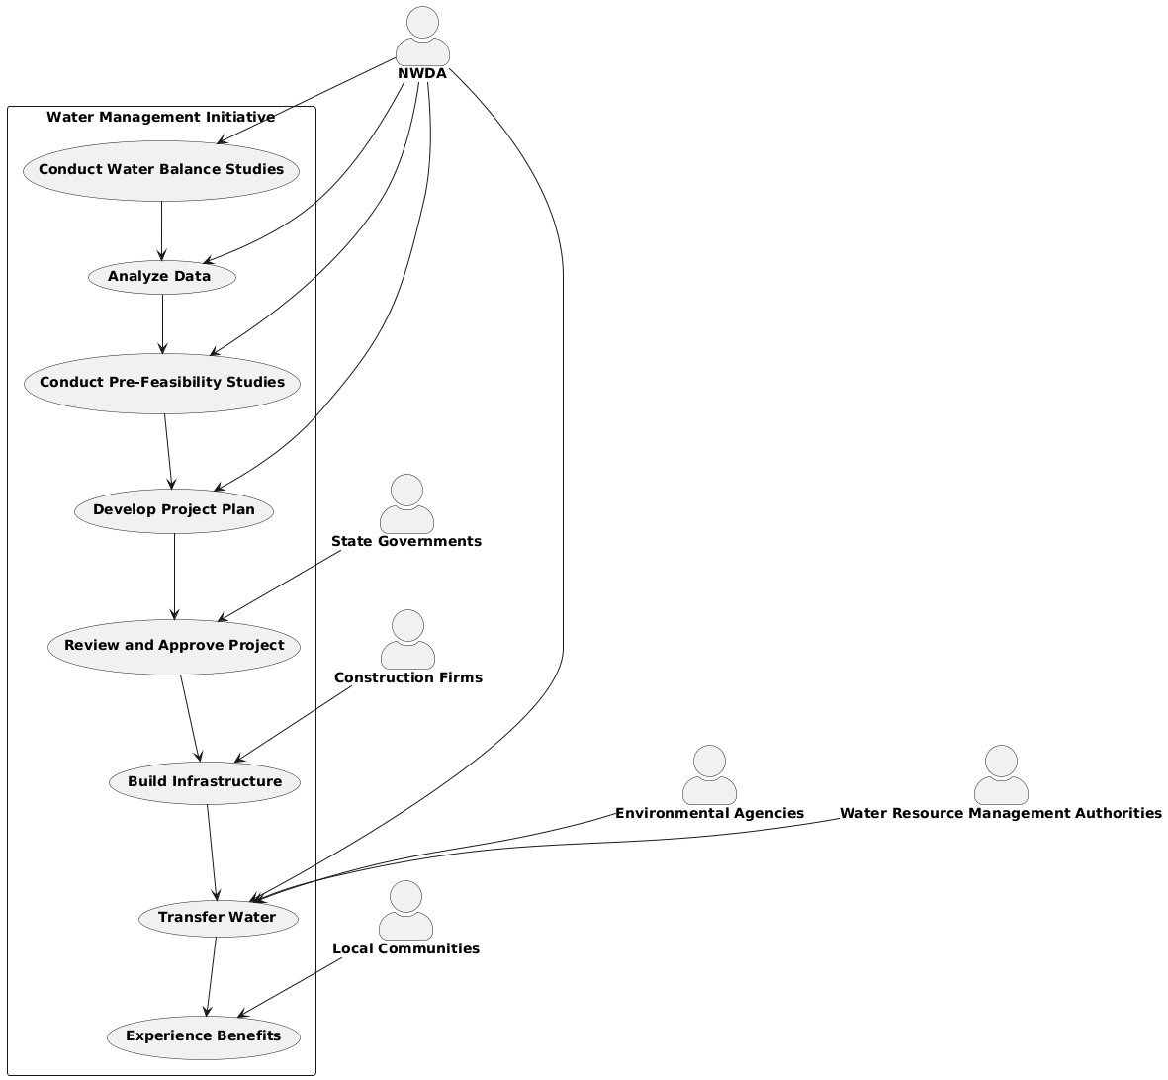

**Code Figure_001_Intro_usecase_Plant uml:-**

@startuml

skinparam actorstyle awesome

actor "**NWDA**" as NWDA

actor "**State Governments**" as StateGov

actor "**Local Communities**" as LocalComm

actor "**Environmental Agencies**" as EnvAgencies

actor "**Construction Firms**" as ConstFirms

actor "**Water Resource Management Authorities**" as WRMA

rectangle "Water Management Initiative" {

(**Conduct Water Balance Studies**)as StudyPhase

(**Analyze Data**) as Analysis

(**Conduct Pre-Feasibility Studies**) as PreFeasibility

(**Develop Project Plan**) as ProjectPlanning

(**Review and Approve Project**) as ApprovalFunding

(**Build Infrastructure**) as Construction

(**Transfer Water**) as Implementation

(**Experience Benefits**) as BenefitsRealization

}

NWDA --> StudyPhase

NWDA --> Analysis

NWDA --> PreFeasibility

NWDA --> ProjectPlanning

StateGov --> ApprovalFunding

ConstFirms --> Construction

NWDA --> Implementation

LocalComm --> BenefitsRealization

EnvAgencies --> Implementation

WRMA --> Implementation

StudyPhase --> Analysis

Analysis --> PreFeasibility

PreFeasibility --> ProjectPlanning

ProjectPlanning --> ApprovalFunding

ApprovalFunding --> Construction

Construction --> Implementation

Implementation --> BenefitsRealization

@enduml

**Diagram_Figure_001_Intro_usecase_Notgpt :-**

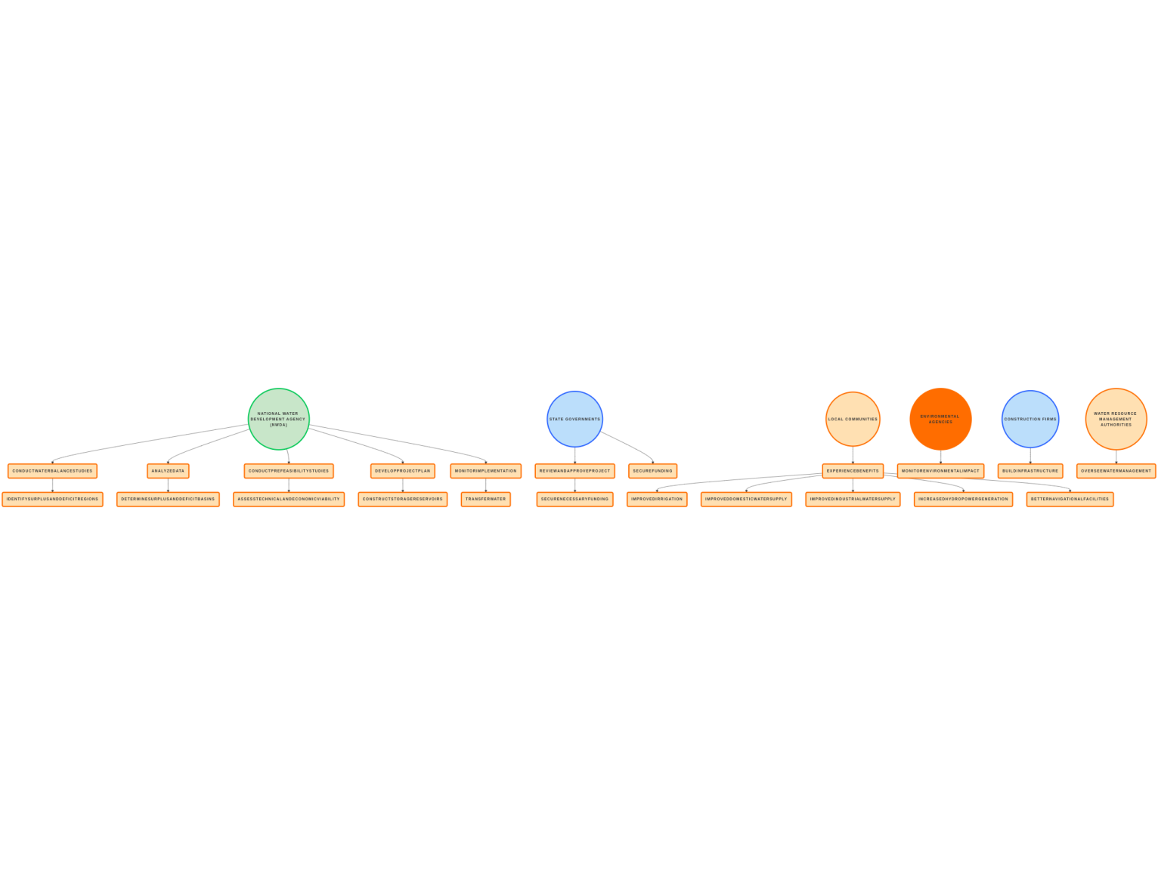

**Code For Figure_001_Intro_usecase_Notgpt :-**

@startuml

left to right direction

RECTANGLE "National Water Development Agency (NWDA)" as NWDA

RECTANGLE "State Governments" as StateGov

RECTANGLE "Local Communities" as LocalComm

RECTANGLE "Environmental Agencies" as EnvAgencies

RECTANGLE "Construction Firms" as ConstFirms

RECTANGLE "Water Resource Management Authorities" as WRMA

NWDA --> (Conduct Water Balance Studies)

NWDA --> (Analyze Data)

NWDA --> (Conduct Pre-Feasibility Studies)

NWDA --> (Develop Project Plan)

NWDA --> (Monitor Implementation)

StateGov --> (Review and Approve Project)

StateGov --> (Secure Funding)

LocalComm --> (Experience Benefits)

EnvAgencies --> (Monitor Environmental Impact)

ConstFirms --> (Build Infrastructure)

WRMA --> (Oversee Water Management)

(Conduct Water Balance Studies) --> (Identify Surplus and Deficit Regions)

(Analyze Data) --> (Determine Surplus and Deficit Basins)

(Conduct Pre-Feasibility Studies) --> (Assess Technical and Economic Viability)

(Develop Project Plan) --> (Construct Storage Reservoirs)

(Review and Approve Project) --> (Secure Necessary Funding)

(Monitor Implementation) --> (Transfer Water)

(Experience Benefits) --> (Improved Irrigation)

(Experience Benefits) --> (Improved Domestic Water Supply)

(Experience Benefits) --> (Improved Industrial Water Supply)

(Experience Benefits) --> (Increased Hydropower Generation)

(Experience Benefits) --> (Better Navigational Facilities)

@enduml

**Diagram_Figure_001_Intro_usecase_diagramly :-**

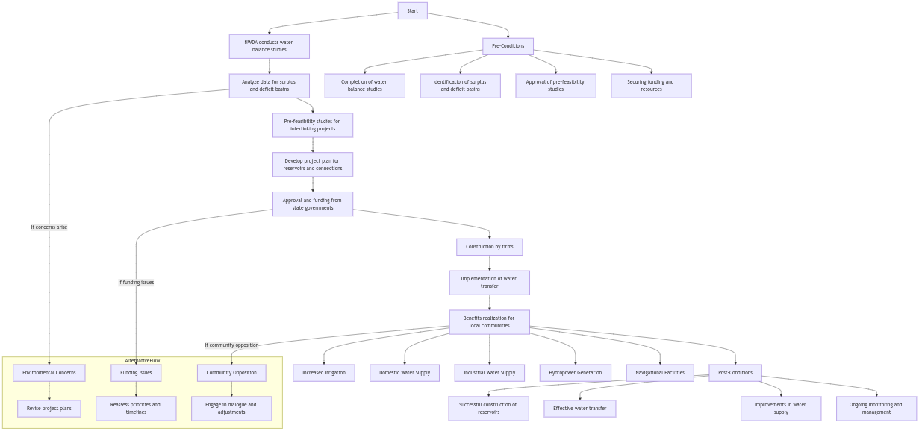

**Mermiad Figure_001_Intro_usecase_diagramly :-**

flowchart TD

Start --> NWDA[NWDA conducts water balance studies]

NWDA --> Analyze[Analyze data for surplus and deficit basins]

Analyze --> Prefeasibility[Pre-feasibility studies for interlinking projects]

Prefeasibility --> ProjectPlan[Develop project plan for reservoirs and connections]

ProjectPlan --> Approval[Approval and funding from state governments]

Approval --> Construction[Construction by firms]

Construction --> Implementation[Implementation of water transfer]

Implementation --> Benefits[Benefits realization for local communities]

subgraph AlternativeFlow

direction TB

Environmental[Environmental Concerns] --> Revise[Revise project plans]

Funding[Funding Issues] --> Reassess[Reassess priorities and timelines]

Community[Community Opposition] --> Engage[Engage in dialogue and adjustments]

end

Analyze -->|If concerns arise| Environmental

Approval -->|If funding issues| Funding

Benefits -->|If community opposition| Community

Benefits --> Irrigation[Increased Irrigation]

Benefits --> DomesticWater[Domestic Water Supply]

Benefits --> IndustrialWater[Industrial Water Supply]

Benefits --> Hydropower[Hydropower Generation]

Benefits --> Navigation[Navigational Facilities]

Start --> PreConditions[Pre-Conditions]

PreConditions --> WaterBalance[Completion of water balance studies]

PreConditions --> BasinID[Identification of surplus and deficit basins]

PreConditions --> StudyApproval[Approval of pre-feasibility studies]

PreConditions --> FundingResources[Securing funding and resources]

Benefits --> PostConditions[Post-Conditions]

PostConditions --> Reservoirs[Successful construction of reservoirs]

PostConditions --> WaterTransfer[Effective water transfer]

PostConditions --> WaterSupply[Improvements in water supply]

PostConditions --> Monitoring[Ongoing monitoring and management]

**Used By (EndUsers):-** Researchers, Decision makers, administrators, academicians, and the public in general.

**Summary:-**

The use case for the end user involves a diverse group of actors, including researchers, decision makers, administrators, academicians, and the public, who interact with an information access and decision support system. The main flow begins with user registration and login, allowing users to search for relevant data, utilize analytical tools, generate reports, and collaborate with others while providing feedback on the system's usability. Alternative flows address potential issues such as access denial, data unavailability, technical problems, and the need for user training. The system offers numerous benefits, including enhanced research capabilities, informed decision-making, efficient administration, academic advancement, and increased public awareness. Pre-conditions for effective use include the system's development, valid user accounts, organized data availability, and accessible training materials. Post-conditions reflect active user engagement, effective data utilization, continuous system improvement, and a more informed community, ultimately fostering greater civic engagement and participation.

**Diagram_Figure_002_Enduser_use case_uml:-**

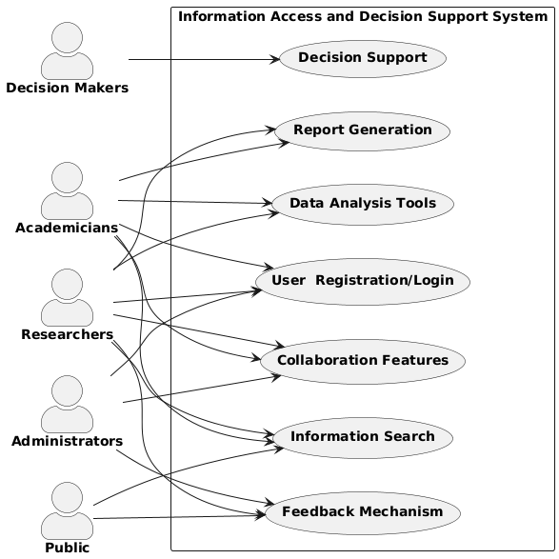

**Code for Figure_002_Enduser_use case_uml:-**

@startuml

left to right direction

skinparam actorstyle awesome

actor "**Researchers**" as Researchers

actor "**Decision Makers**" as DecisionMakers

actor "**Administrators**" as Administrators

actor "**Academicians**" as Academicians

actor "**Public**" as Public

rectangle "Information Access and Decision Support System" {

usecase "**User Registration/Login**" as UC1

usecase "**Information Search**" as UC2

usecase "**Data Analysis Tools**" as UC3

usecase "**Report Generation**" as UC4

usecase "**Collaboration Features**" as UC5

usecase "**Feedback Mechanism**" as UC6

usecase "**Decision Support**" as UC7

}

Researchers --> UC1

Researchers --> UC2

Researchers --> UC3

Researchers --> UC4

Researchers --> UC5

Researchers --> UC6

DecisionMakers --> UC7

Administrators --> UC1

Administrators --> UC5

Administrators --> UC6

Academicians --> UC1

Academicians --> UC2

Academicians --> UC3

Academicians --> UC4

Academicians --> UC5

Public --> UC2

Public --> UC6

@enduml

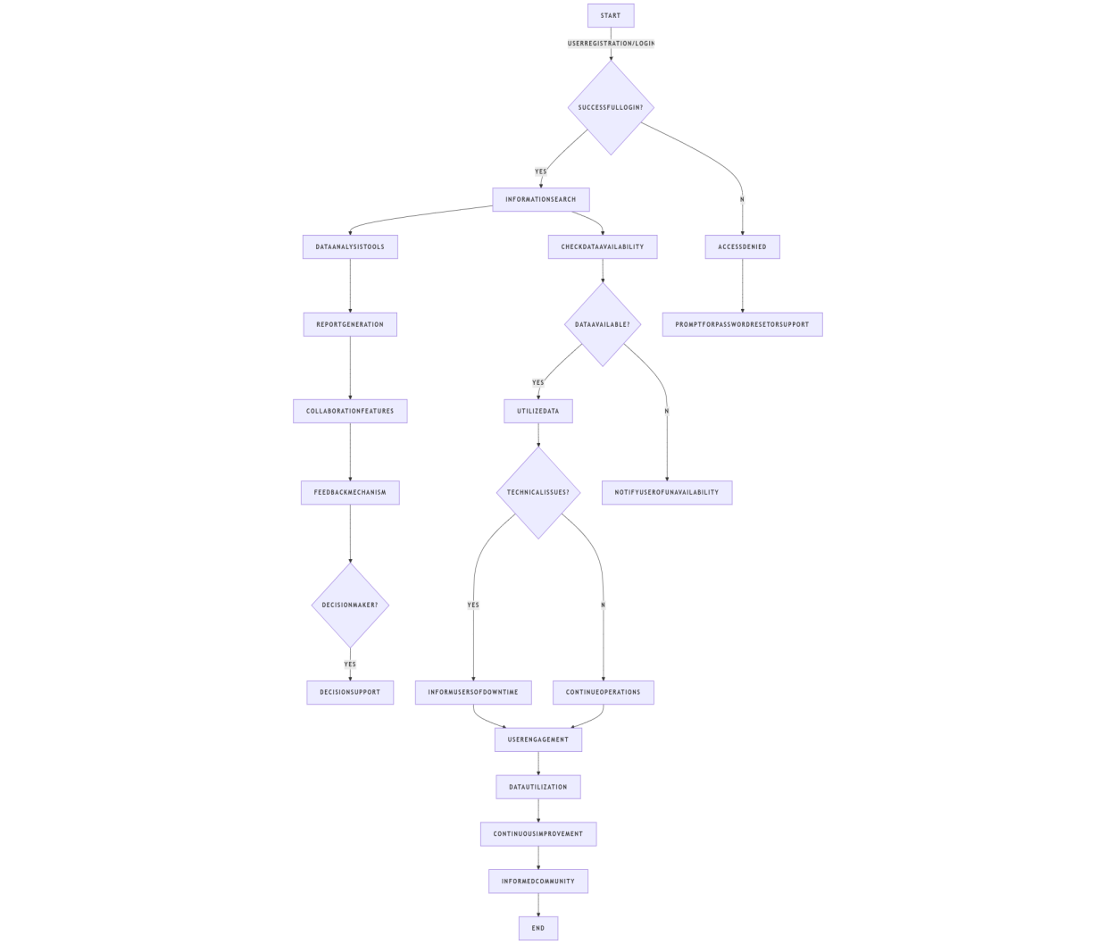**Diagram_Figure_002_Enduser_usecase_notgpt:-**

**Code_for_Figure_002_Enduser_usecase_notgpt:-**

@startuml

start

:User Registration/Login;

if (Successful Login?) then (yes)

:Information Search;

:Data Analysis Tools;

:Report Generation;

:Collaboration Features;

:Feedback Mechanism;

if (Decision Maker?) then (yes)

:Decision Support;

endif

else (no)

:Access Denied;

:Prompt for Password Reset or Support;

endif

:Check Data Availability;

if (Data Available?) then (yes)

:Utilize Data;

else (no)

:Notify User of Unavailability;

endif

:Technical Issues?;

if (Yes) then (yes)

:Inform Users of Downtime;

else (no)

:Continue Operations;

endif

:User Engagement;

:Data Utilization;

:Continuous Improvement;

:Informed Community;

stopflowchart TD

A[User Registration/Login] --> B{Successful Login?}

B -- Yes --> C[Information Search]

C --> D[Data Analysis Tools]

D --> E[Report Generation]

E --> F[Collaboration Features]

F --> G[Feedback Mechanism]

G --> H{Decision Maker?}

H -- Yes --> I[Decision Support]

B -- No --> J[Access Denied]

J --> K[Prompt for Password Reset]

C --> L{Data Available?}

L -- Yes --> M[Utilize Data]

L -- No --> N[Notify User of Unavailability]

O{Technical Issues?}

O -- Yes --> P[Inform Users of Downtime]

O -- No --> Q[Continue Operations]

R[User Engagement] --> S[Data Utilization]

S --> T[Continuous Improvement]

T --> U[Informed Community]@enduml

**Diagram_Figure_002_Enduser_usecase_diagramly :-**

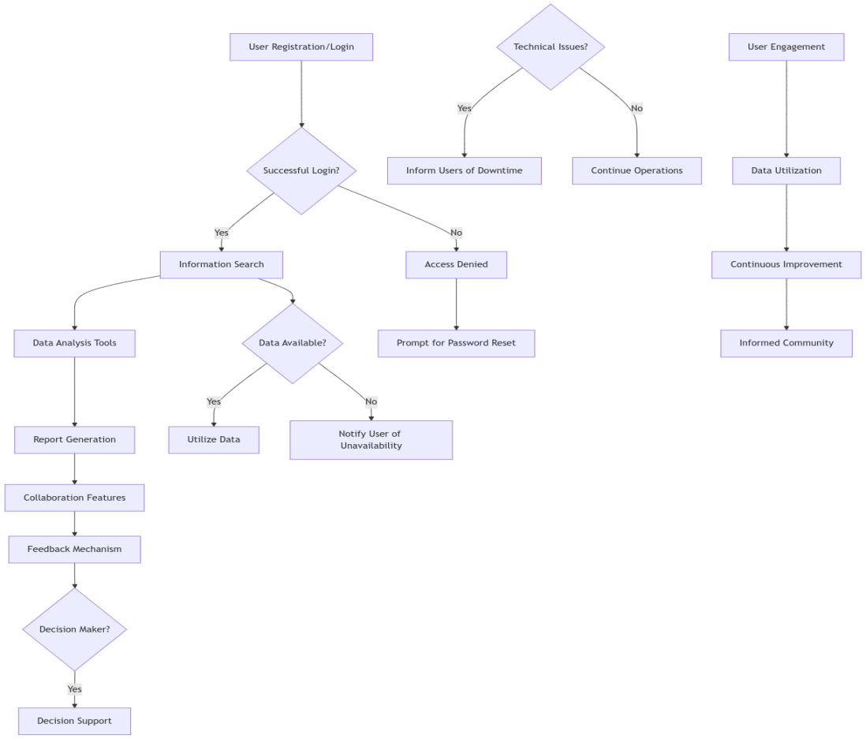

**Code_for_Figure_002_Enduser_usecase_Digramly:-**

flowchart TD

A[User Registration/Login] --> B{Successful Login?}

B -- Yes --> C[Information Search]

C --> D[Data Analysis Tools]

D --> E[Report Generation]

E --> F[Collaboration Features]

F --> G[Feedback Mechanism]

G --> H{Decision Maker?}

H -- Yes --> I[Decision Support]

B -- No --> J[Access Denied]

J --> K[Prompt for Password Reset]

C --> L{Data Available?}

L -- Yes --> M[Utilize Data]

L -- No --> N[Notify User of Unavailability]

@startuml

left to right direction

skinparam actorstyle awesome

actor "**Project Manager**" as PM

actor "**Team Members**" as TM

actor "**Stakeholders**" as SH

actor "**System Administrator**" as SA

rectangle "Manage High Priority Task" {

(**Identify High Priority Task**) as IdentifyTask

(**Assign Team Members**) as AssignMembers

(**Set Deadlines**) as SetDeadlines

(**Notify Team Members**) as NotifyMembers

(**Monitor Progress**) as MonitorProgress

(**Provide Support**) as ProvideSupport

(**Complete Task**) as CompleteTask

(**Review and Approve**) as ReviewApprove

(**Notify Stakeholders**) as NotifyStakeholders

}

PM --> IdentifyTask

PM --> AssignMembers

PM --> SetDeadlines

PM --> NotifyMembers

PM --> MonitorProgress

PM --> ProvideSupport

TM --> CompleteTask

PM --> ReviewApprove

SH --> NotifyStakeholders

@enduml

O{Technical Issues?}

O -- Yes --> P[Inform Users of Downtime]

O -- No --> Q[Continue Operations]

R[User Engagement] --> S[Data Utilization]

S --> T[Continuous Improvement]

T --> U[Informed Community]

**Priority**:- **High Priority**

**Description:-**

The designation of "High Priority" indicates that a task, project, or initiative is of utmost importance and requires immediate attention and action. This classification is typically assigned to activities that have significant implications for organizational goals, stakeholder interests, or operational efficiency.

**Reframe:-**

The label "High Priority" signifies that a task, project, or initiative holds critical importance and necessitates prompt attention and action. This classification is generally applied to activities that have substantial consequences for organizational objectives, stakeholder interests, or operational effectiveness.

**Use case:-**

**Actors:**

1. Project Manager: Responsible for overseeing the task and ensuring it is completed on time.
2. Team Members: Individuals assigned to work on the task.
3. Stakeholders: Individuals or groups with an interest in the task's outcome.
4. System Administrator: Manages the project management system.

**Main Flow:**

1. Identify High Priority Task: The Project Manager identifies a task that is classified as high priority.
2. Assign Team Members: The Project Manager assigns team members to the task.
3. Set Deadlines: The Project Manager sets a deadline for task completion.
4. Notify Team Members: The system sends notifications to assigned team members about their responsibilities and deadlines.
5. Monitor Progress: The Project Manager regularly checks the progress of the task through the project management system.
6. Provide Support: Team members can request assistance or resources from the Project Manager as needed.
7. Complete Task: Team members complete the task and update its status in the system.
8. Review and Approve: The Project Manager reviews the completed task and approves it if it meets the requirements.
9. Notify Stakeholders: The system notifies stakeholders of the task completion and its outcomes.

**Alternative Flow:**

* If Team Members Encounter Issues:
  + Team members report issues to the Project Manager.
  + The Project Manager assesses the situation and reallocates resources or adjusts deadlines as necessary.
  + The system updates the task status to reflect any changes.
* If Task Cannot Be Completed on Time:
  + The Project Manager communicates with stakeholders about the delay.
  + A revised timeline is established, and the system is updated accordingly.

**Benefits:**

* Improved Efficiency: High-priority tasks are managed effectively, leading to timely completion.
* Enhanced Communication: Clear notifications and updates keep all stakeholders informed.
* Resource Optimization: Proper allocation of resources ensures that team members have what they need to succeed.
* Increased Accountability: Team members are aware of their responsibilities and deadlines.

**Pre conditions:**

* The project management system is operational and accessible to all actors.
* The Project Manager has identified and classified the task as high priority.
* Team members are available and have the necessary skills to complete the task.

**Post conditions:**

* The high-priority task is completed and approved by the Project Manager.
* Stakeholders are informed of the task's completion and its impact.
* The project management system reflects the updated status of the task and any lessons learned for future reference.

**Summary:-**

The designation of "High Priority" indicates that a task, project, or initiative is of critical importance and requires immediate attention due to its significant impact on organizational goals and stakeholder interests. In the use case, the Project Manager oversees the identification and management of high-priority tasks, assigning team members, setting deadlines, and monitoring progress through a project management system. The process includes notifying team members, providing support, and reviewing completed tasks, while also addressing any issues that may arise. Benefits of this approach include improved efficiency, enhanced communication, optimized resource allocation, and increased accountability. Preconditions for this workflow include an operational project management system and the availability of skilled team members, while post conditions ensure that tasks are completed, stakeholders are informed, and the system reflects updated statuses and lessons learned.

**Diagram_Figure_003_Priority_usecase_Plantuml:-**

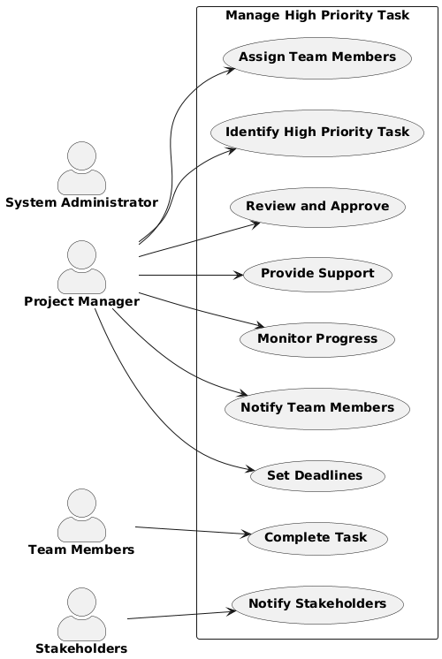

**Code_for_Figure_003_Priority_usecase_Plantuml:-**

@startuml

left to right direction

skinparam actorstyle awesome

actor "**Project Manager**" as PM

actor "**Team Members**" as TM

actor "**Stakeholders**" as SH

actor "**System Administrator**" as SA

rectangle "Manage High Priority Task" {

(**Identify High Priority Task**) as IdentifyTask

(**Assign Team Members**) as AssignMembers

(**Set Deadlines**) as SetDeadlines

(**Notify Team Members**) as NotifyMembers

(**Monitor Progress**) as MonitorProgress

(**Provide Support**) as ProvideSupport

(**Complete Task**) as CompleteTask

(**Review and Approve**) as ReviewApprove

(**Notify Stakeholders**) as NotifyStakeholders

}

PM --> IdentifyTask

PM --> AssignMembers

PM --> SetDeadlines

PM --> NotifyMembers

PM --> MonitorProgress

PM --> ProvideSupport

TM --> CompleteTask

PM --> ReviewApprove

SH --> NotifyStakeholders

@enduml

**Diagram_Figure_003_Priority_usecase_Notgpt:-**

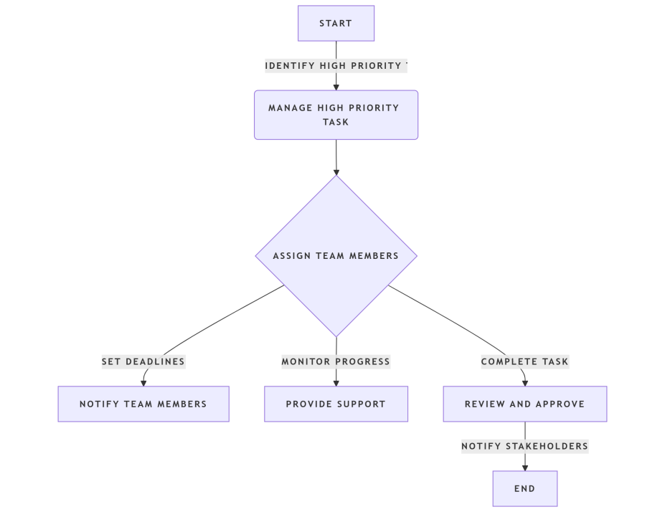

**Code_for_Figure_003_Priority_usecase_Notgpt:-**

@startuml

left to right direction

skinparam actorstyle awesome

actor "**Project Manager**" as PM

actor "**Team Members**" as TM

actor "**Stakeholders**" as SH

actor "**System Administrator**" as SA

rectangle "Manage High Priority Task" {

(**Identify High Priority Task**) as IdentifyTask

(**Assign Team Members**) as AssignMembers

(**Set Deadlines**) as SetDeadlines

(**Notify Team Members**) as NotifyMembers

(**Monitor Progress**) as MonitorProgress

(**Provide Support**) as ProvideSupport

(**Complete Task**) as CompleteTask

(**Review and Approve**) as ReviewApprove

(**Notify Stakeholders**) as NotifyStakeholders

}

PM --> IdentifyTask

PM --> AssignMembers

PM --> SetDeadlines

PM --> NotifyMembers

PM --> MonitorProgress

PM --> ProvideSupport

TM --> CompleteTask

PM --> ReviewApprove

SH --> NotifyStakeholders

@enduml

**Diagram_Figure_003_Priority_usecase_Mermaidjs:-**

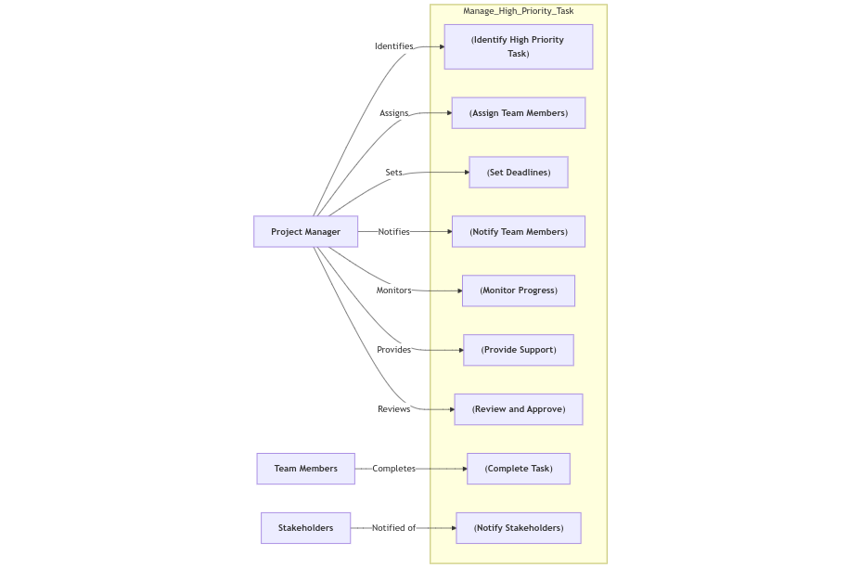

**Code_for_Figure_003_Priority_usecase_mermaidjs:-**

%%{ init : { "theme" : "default", "themeVariables": { "background": "#ffffff", "primaryColor": "#000000", "edgeLabelBackground":"#ffffff", "tertiaryColor": "#ffffff" } } }%%

graph LR

PM["**Project Manager**"] -->|Identifies| IdentifyTask["(**Identify High Priority Task**)"]

PM -->|Assigns| AssignMembers["(**Assign Team Members**)"]

PM -->|Sets| SetDeadlines["(**Set Deadlines**)"]

PM -->|Notifies| NotifyMembers["(**Notify Team Members**)"]

PM -->|Monitors| MonitorProgress["(**Monitor Progress**)"]

PM -->|Provides| ProvideSupport["(**Provide Support**)"]

TM["**Team Members**"] -->|Completes| CompleteTask["(**Complete Task**)"]

PM -->|Reviews| ReviewApprove["(**Review and Approve**)"]

SH["**Stakeholders**"] -->|Notified of| NotifyStakeholders["(**Notify Stakeholders**)"]

subgraph Manage_High_Priority_Task

IdentifyTask

AssignMembers

SetDeadlines

NotifyMembers

MonitorProgress

ProvideSupport

CompleteTask

ReviewApprove

NotifyStakeholders

end

**Phase:-Phase 1 WIMS-expansion-WRIS**

**Governance Need (Business Problem):-**

**Issue**:-

1. Survey sheets done by National Waterways Development authority was provided in the hard copy formats that requires digitization and further GIS operations for hosting in the module. Manual error while generation of the GIS data in different stages of data creation may increase.
2. Information provided are extracted from the pre-feasibility and feasibility studies for 16 probable peninsular links. Each link, in this component is briefly described here. This information is tentative and likely to change at DPR stage. Updated informations need to be incorporated into the module.
3. NWDA has completed the pre-feasibility studies of 14 links in the Himalayan Component. Those data are not incorporated into the module yet.

**Reframe:-**

1. Digitization of Survey Sheets: The survey sheets provided by the National Waterways Development Authority are in hard copy format, necessitating digitization and subsequent GIS operations for integration into the module. This process may introduce manual errors during the various stages of GIS data generation.
2. Tentative Information from Studies: The information extracted from the pre-feasibility and feasibility studies for 16 potential peninsular links is currently tentative and subject to change during the Detailed Project Report (DPR) stage. It is essential to update the module with the latest information as it becomes available.
3. Incomplete Data for Himalayan Links: The NWDA has completed pre-feasibility studies for 14 links in the Himalayan Component; however, this data has not yet been incorporated into the module.

**Use case:-**

**Actors:**

1. Data Entry Personnel: Individuals responsible for digitizing hard copy survey sheets and entering data into the system.
2. GIS Analysts: Specialists who perform GIS operations and ensure the accuracy of the spatial data.
3. Project Managers: Individuals overseeing the project who require updated information for decision-making.
4. NWDA (National Water Development Authority): The organization providing the survey data and studies.
5. End Users: Stakeholders who will utilize the integrated data for planning and analysis.

**Main Flow:**

1. Receive Hard Copy Survey Sheets: Data Entry Personnel receive the hard copy survey sheets from NWDA.
2. Digitization: Data Entry Personnel digitize the survey sheets into a digital format.
3. Initial Data Validation: The digitized data undergoes initial validation to check for errors.
4. GIS Data Generation: GIS Analysts use the digitized data to create GIS datasets.
5. GIS Data Validation: GIS Analysts validate the GIS data to ensure accuracy and completeness.
6. Incorporate Tentative Information: Information from pre-feasibility and feasibility studies for the 16 peninsular links is integrated into the module.
7. Update Module: The module is updated with the latest information, including any changes identified during the DPR stage.
8. Incorporate Himalayan Data: The pre-feasibility studies for the 14 Himalayan links are incorporated into the module once available.

**Alternative Flow:**

* Error in Digitization: If errors are found during initial data validation, the data entry personnel must correct the errors and revalidate the data.
* Incomplete Data: If the information from the pre-feasibility and feasibility studies is incomplete, the project manager must request additional data from NWDA.
* Technical Issues: If technical issues arise during GIS operations, GIS Analysts must troubleshoot the issues or escalate them to IT support.
* Changes in Tentative Information: If the information changes during the DPR stage, the project manager must ensure that the updated information is incorporated into the module.

**Benefits:**

* Improved Data Accessibility: Digitization allows for easier access to survey data and GIS information.
* Enhanced Decision-Making: Project managers and stakeholders can make informed decisions based on accurate and up-to-date data.
* Reduced Manual Errors: Implementing a structured digitization and validation process minimizes the risk of manual errors.
* Comprehensive Data Integration: Incorporating both peninsular and Himalayan data provides a holistic view of the waterways development project.

**Pre-Conditions:**

* Availability of Hard Copy Survey Sheets: The hard copy survey sheets must be provided by NWDA.
* Digitization Tools: Necessary tools and software for digitization and GIS operations must be available.
* Training for Personnel: Data entry personnel and GIS analysts must be trained in the digitization and GIS processes.
* Access to Updated Information: There must be a mechanism in place to receive updated information from NWDA during the DPR stage.

**Post-Conditions:**

* Successful Digitization: All hard copy survey sheets are successfully digitized and validated.
* Accurate GIS Data: GIS datasets are generated and validated for accuracy.
* Updated Module: The module contains the latest information from both peninsular and Himalayan studies.
* Ongoing Data Management: A process is established for continuous updates and management of the data as new information becomes available.

**Summary:-**

The use case involves several key actors, including Data Entry Personnel, GIS Analysts, Project Managers, the National Water Development Authority (NWDA), and End Users, who collectively work on digitizing hard copy survey sheets and integrating data into a module for waterways development. The main flow begins with the receipt of survey sheets from NWDA, followed by digitization, initial validation, GIS data generation, and validation, ultimately leading to the incorporation of tentative information from pre-feasibility studies for 16 peninsular links and the 14 Himalayan links. Alternative flows address potential issues such as errors in digitization, incomplete data, technical problems, and changes in information during the Detailed Project Report (DPR) stage. The process offers benefits like improved data accessibility, enhanced decision-making, reduced manual errors, and comprehensive data integration. Pre-conditions include the availability of hard copy sheets, necessary tools, trained personnel, and mechanisms for receiving updated information, while post-conditions ensure successful digitization, accurate GIS data, an updated module, and ongoing data management for continuous improvement.

**Diagram_Figure_004_Issue_usecase_PlantUML:-**

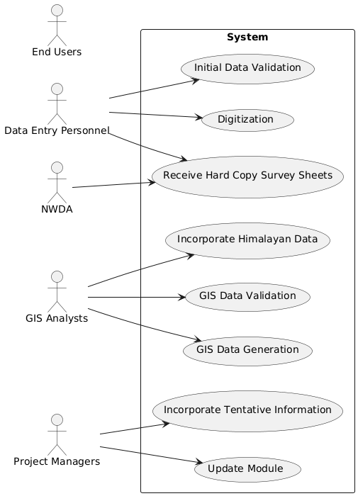

**Code_for_Figure_004_Issue_usecase_PlantUML:-**

@startuml

left to right direction

RECTANGLE System {

usecase "Receive Hard Copy Survey Sheets" as UC1

usecase "Digitization" as UC2

usecase "Initial Data Validation" as UC3

usecase "GIS Data Generation" as UC4

usecase "GIS Data Validation" as UC5

usecase "Incorporate Tentative Information" as UC6

usecase "Update Module" as UC7

usecase "Incorporate Himalayan Data" as UC8

}

actor "Data Entry Personnel" as DEP

actor "GIS Analysts" as GA

actor "Project Managers" as PM

actor "NWDA" as NWDA

actor "End Users" as EU

DEP --> UC1

DEP --> UC2

DEP --> UC3

GA --> UC4

GA --> UC5

PM --> UC6

PM --> UC7

GA --> UC8

NWDA --> UC1

@enduml

**Diagram_Figure_004_Issue_usecase_Notgpt:-**

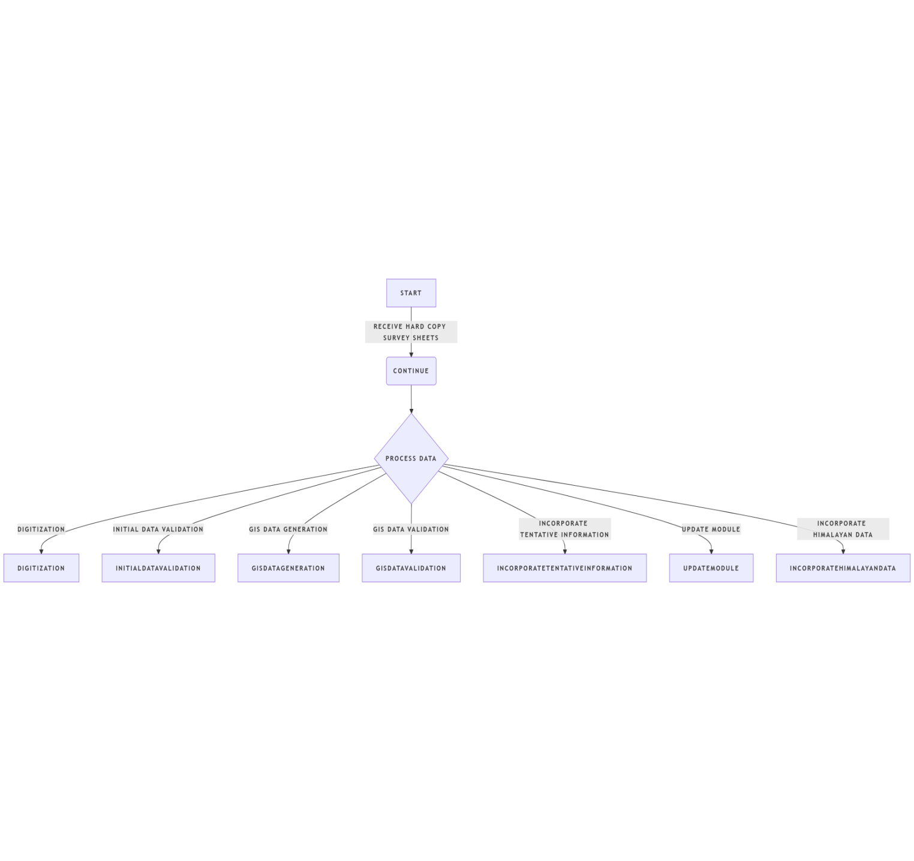

**Code_for_Figure_004_Issue_usecase_Notgpt:-**

@startuml

left to right direction

RECTANGLE System {

usecase "Receive Hard Copy Survey Sheets" as UC1

usecase "Digitization" as UC2

usecase "Initial Data Validation" as UC3

usecase "GIS Data Generation" as UC4

usecase "GIS Data Validation" as UC5

usecase "Incorporate Tentative Information" as UC6

usecase "Update Module" as UC7

usecase "Incorporate Himalayan Data" as UC8

}

actor "Data Entry Personnel" as DEP

actor "GIS Analysts" as GA

actor "Project Managers" as PM

actor "NWDA" as NWDA

actor "End Users" as EU

DEP --> UC1

DEP --> UC2

DEP --> UC3

GA --> UC4

GA --> UC5

PM --> UC6

PM --> UC7

GA --> UC8

NWDA --> UC1

@enduml

**Diagram_Figure_004_Issue_usecase_Diagramly:-**

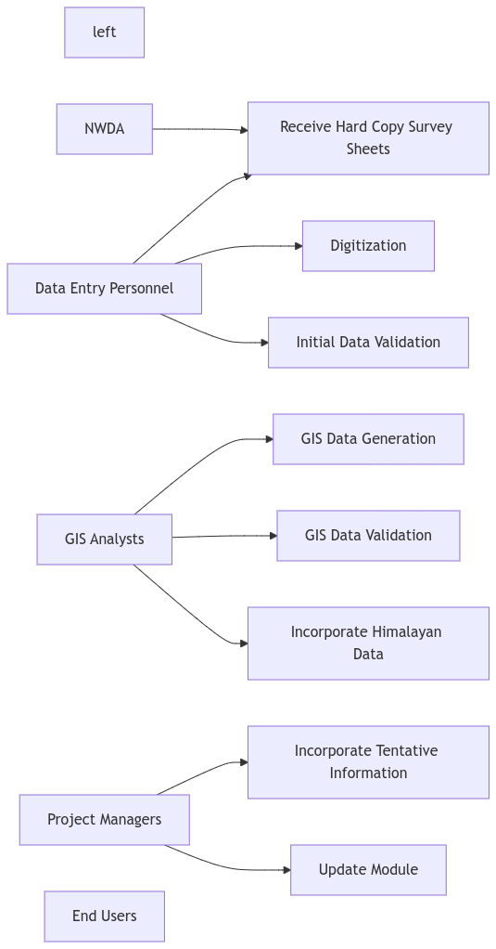

**Code_for_Figure_004_Issue_usecase_Diagramly:-**

flowchart LR

left

%% Actors

A1[Data Entry Personnel]

A2[GIS Analysts]

A3[Project Managers]

A4[NWDA]

A5[End Users]

%% Use Cases

UC1[Receive Hard Copy Survey Sheets]

UC2[Digitization]

UC3[Initial Data Validation]

UC4[GIS Data Generation]

UC5[GIS Data Validation]

UC6[Incorporate Tentative Information]

UC7[Update Module]

UC8[Incorporate Himalayan Data]

%% Relationships

A4 --> UC1

A1 --> UC1

A1 --> UC2

A1 --> UC3

A2 --> UC4

A2 --> UC5

A3 --> UC6

A3 --> UC7

A2 --> U

**Approach**:-

**Output:-**Mapping Of the proposed 30 Possible Inter Basin Transfer Links in India, Which include 14 Himalayan And 16 peninsular components.

**Expected Outcome:-** Inter-Basin Transfer Links module offers information of the various components of the proposed Inter Basin Transfer Links as per the study conducted by National Water Development Agency. User can view & download the information of the salient features, executive summary, water transfer routes (canals and tunnels), the detailed structures and water bodies associated with the IBTLs and tentative surface profile (derived using SRTM DEM 90m) for the 16peninsula components. Facilities are also provided to view & download the information of salient features, executive summary and maps for the 14 Himalayan components.

**Diagram_Figure_005_Expected-outcome_PlantUML:-**

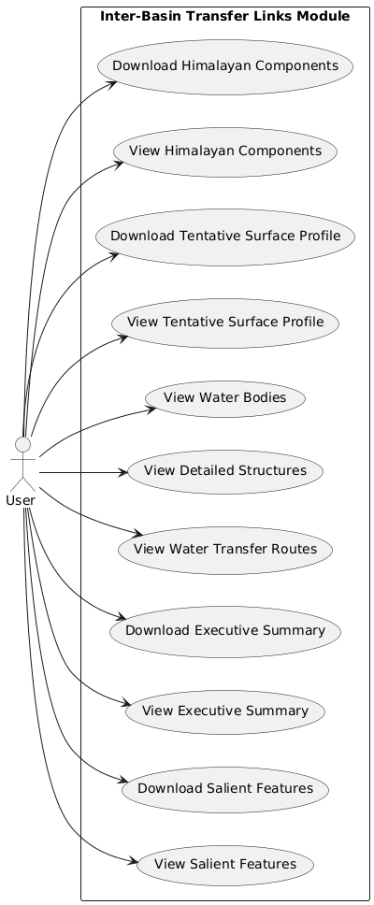

**Code_for_Figure_005_Expected-outcome_PlanUML:-**

@startuml

left to right direction

actor "User " as U

rectangle "Inter-Basin Transfer Links Module" {

usecase "View Salient Features" as UC1

usecase "Download Salient Features" as UC2

usecase "View Executive Summary" as UC3

usecase "Download Executive Summary" as UC4

usecase "View Water Transfer Routes" as UC5

usecase "View Detailed Structures" as UC6

usecase "View Water Bodies" as UC7

usecase "View Tentative Surface Profile" as UC8

usecase "Download Tentative Surface Profile" as UC9

usecase "View Himalayan Components" as UC10

usecase "Download Himalayan Components" as UC11

}

U --> UC1

U --> UC2

U --> UC3

U --> UC4

U --> UC5

U --> UC6

U --> UC7

U --> UC8

U --> UC9

U --> UC10

U --> UC11

@enduml

**Diagram_Figure_005_Expected-outcome_Notgpt:-**

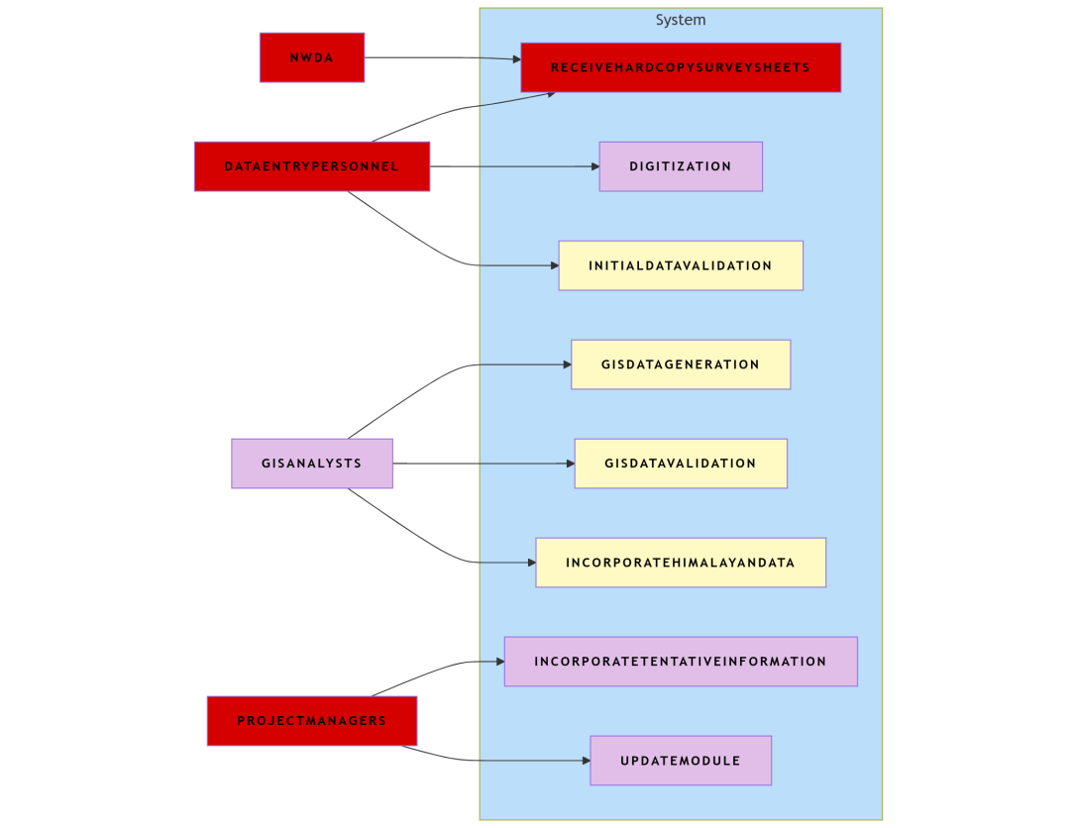

**Code_for_Figure_005_Expected-outcome_Notgpt:-**

@startuml

RECTANGLE System {

usecase "Receive Hard Copy Survey Sheets" as UC1

usecase "Digitization" as UC2

usecase "Initial Data Validation" as UC3

usecase "GIS Data Generation" as UC4

usecase "GIS Data Validation" as UC5

usecase "Incorporate Tentative Information" as UC6

usecase "Update Module" as UC7

usecase "Incorporate Himalayan Data" as UC8

}

actor "Data Entry Personnel" as DEP

actor "GIS Analysts" as GA

actor "Project Managers" as PM

actor "NWDA" as NWDA

actor "End Users" as EU

DEP --> UC1

DEP --> UC2

DEP --> UC3

GA --> UC4

GA --> UC5

PM --> UC6

PM --> UC7

GA --> UC8

NWDA --> UC1

@enduml

**Diagram_Figure_005_Expected-outcome_Diagramly:-**

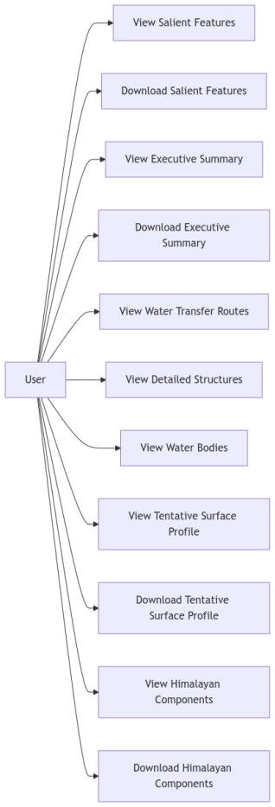

**Code_for_Figure_005_ExpectedOutcome_Diagramly:-**

%%{ init : { "theme" : "default", "flowchart" : { "curve" : "linear" } } }%%

flowchart LR

%% Define actor

actor["User "]

%% Define use cases

UC1["View Salient Features"]

UC2["Download Salient Features"]

UC3["View Executive Summary"]

UC4["Download Executive Summary"]

UC5["View Water Transfer Routes"]

UC6["View Detailed Structures"]

UC7["View Water Bodies"]

UC8["View Tentative Surface Profile"]

UC9["Download Tentative Surface Profile"]

UC10["View Himalayan Components"]

%%{ init : { "theme" : "default", "flowchart" : { "curve" : "linear" } } }%%

flowchart LR

%% Define actor

actor["User "]

%% Define use cases

UC1["View Salient Features"]

UC2["Download Sal%%{ init : { "theme" : "default", "flowchart" : { "curve" : "linear" } } }%%

flowchart LR

%% Define actor

actor["User "]

%% Define use cases

UC1["View Salient Features"]

UC2["Download Salient Features"]

UC3["View Executive Summary"]

UC4["Download Executive Summary"]

UC5["View Water Transfer Routes"]

UC6["View Detailed Structures"]

UC7["View Water Bodies"]

UC8["View Tentative Surface Profile"]

UC9["Download Tentative Surface Profile"]

UC10["View Himalayan Components"]

UC11["Download Himalayan Components"]

%% Define relationships

actor --> UC1

actor --> UC2

actor --> UC3

actor --> UC4

actor --> UC5

actor --> UC6

actor --> UC7

actor --> UC8

actor --> UC9

actor --> UC10

actor --> UC11ient Features"]

UC3["View Executive Summary"]

UC4["Download Executive Summary"]

UC5["View Water Transfer Routes"]

UC6["View Detailed Structures"]

UC7["View Water Bodies"]

UC8["View Tentative Surface Profile"]

UC9["Download Tentative Surface Profile"]

UC10["View Himalayan Components"]

UC11["Download Himalayan Components"]

%% Define relationships

actor --> UC1

actor --> UC2

actor --> UC3

actor --> UC4

actor --> UC5

actor --> UC6

actor --> UC7

actor --> UC8

actor --> UC9

actor --> UC10

actor --> UC11 UC11["Download Himalayan Components"]

%% Define relationships

actor --> UC1

actor --> UC2

actor --> UC3

actor --> UC4

actor --> UC5

actor --> UC6

actor --> UC7

actor --> UC8

actor --> UC9

actor --> UC10

actor --> UC11

**Visualization:-**

**1. Map at India Level:** Map Showing Proposed 30 Possible Inter Basin Transfer Links at India Level;

Fig 1: Inter Basin Transfer links at India Level

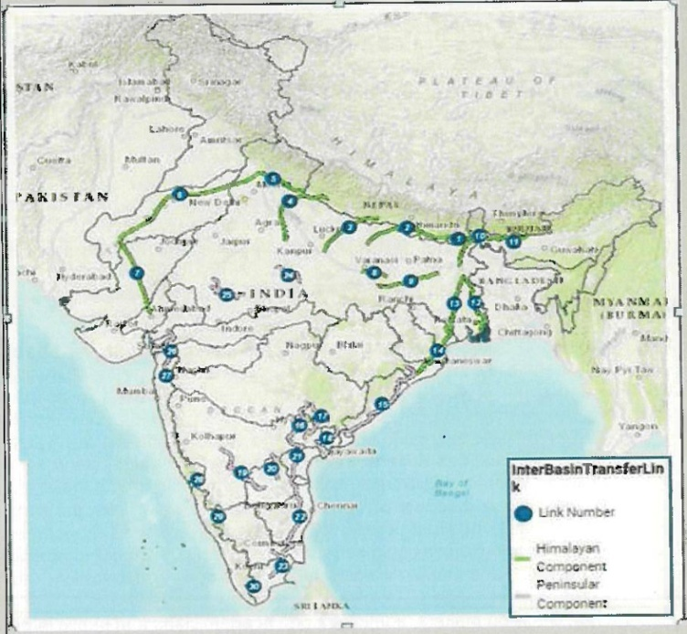

**Diagram_Figure_006_ Visualization_Sequence1_PlantUML:-**

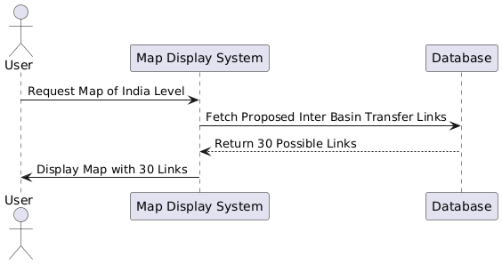

**Code_for_Figure_006_ Visualization_Sequence_PlantUML:-**

@startuml

actor User

participant "Map Display System" as MDS

participant "Database" as DB

User -> MDS: Request Map of India Level

MDS -> DB: Fetch Proposed Inter Basin Transfer Links

DB --> MDS: Return 30 Possible Links

MDS -> User: Display Map with 30 Links

@enduml

**Diagram_Figure_006_ Visualization_Sequence_Notgpt:-**

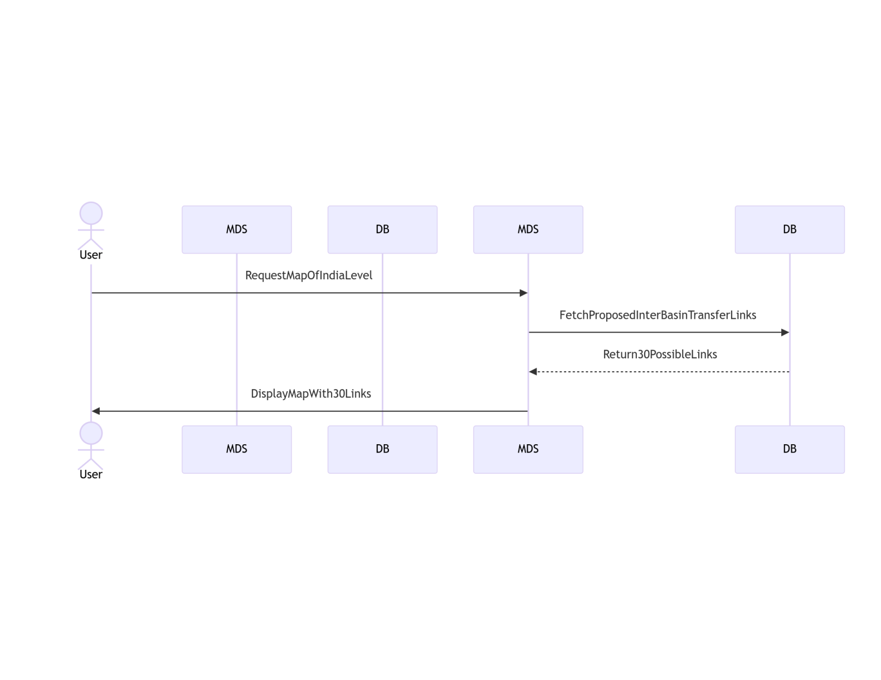

**Code_for_Figure_006_ Visualization_Sequence_Notgpt:-**

@startuml

actor User

participant "Map Display System" as MDS

participant "Database" as DB

User -> MDS: Request Map of India Level

MDS -> DB: Fetch Proposed Inter Basin Transfer Links

DB --> MDS: Return 30 Possible Links

MDS -> User: Display Map with 30 Links

@enduml

2. Map Of Individual Inter basin Transfer Link — Map Regarding particular Inter Basin Transfer Links.

Fig 2: Map of Damanganga Pinjal Link

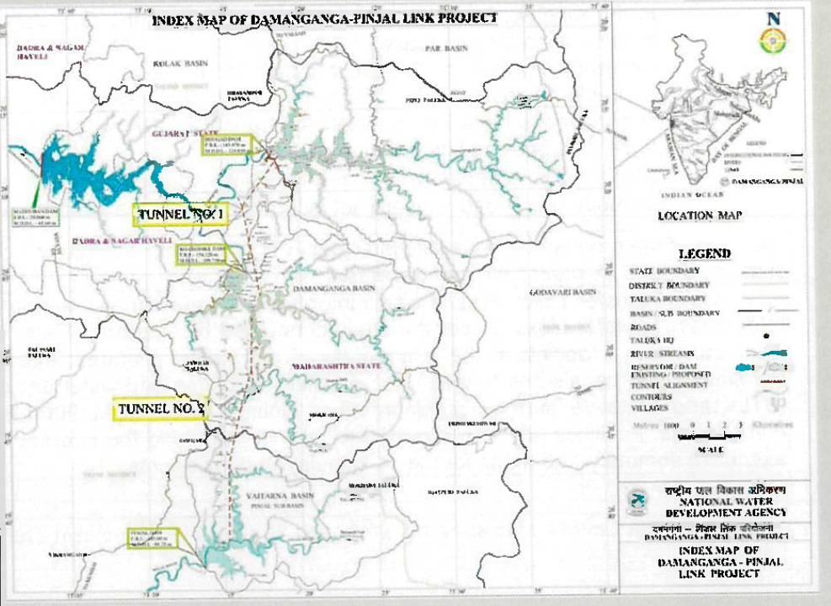

**Diagram_Figure_006_ Visualization_Sequence_PlantUML:-**

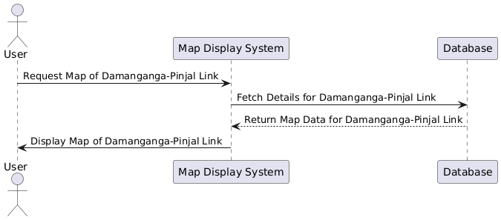

**Code_for_Figure_006_Visualization_Sequence_PlantUML:-**

@startuml

actor User

participant "Map Display System" as MDS

participant "Database" as DB

User -> MDS: Request Map of Damanganga-Pinjal Link

MDS -> DB: Fetch Details for Damanganga-Pinjal Link

DB --> MDS: Return Map Data for Damanganga-Pinjal Link

MDS -> User: Display Map of Damanganga-Pinjal Link

@enduml

**Diagram_Figure_006_Visualization_Sequence_Notgpt:-**

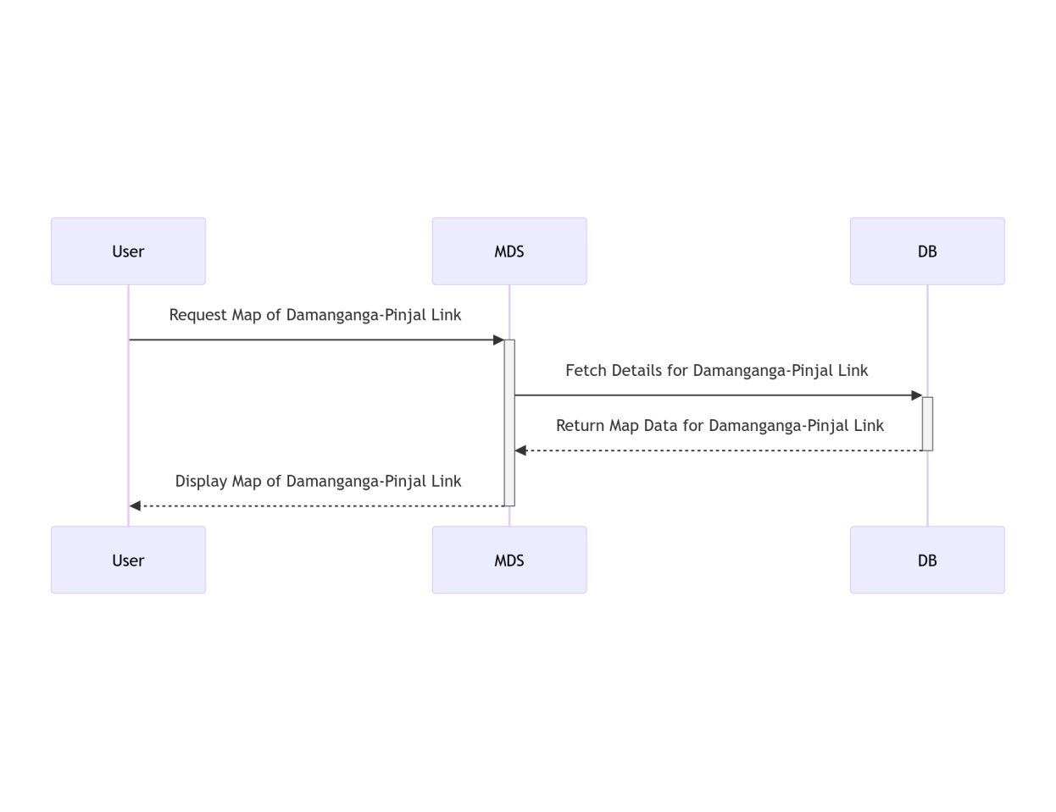

**Code_for_Figure_006_Visualization_Sequence_Notgpt:-**

@startuml

actor User

participant "Map Display System" as MDS

participant "Database" as DB

User -> MDS: Request Map of Damanganga-Pinjal Link

MDS -> DB: Fetch Details for Damanganga-Pinjal Link

DB --> MDS: Return Map Data for Damanganga-Pinjal Link

MDS -> User: Display Map of Damanganga-Pinjal Link

@enduml

**3.Report for Individual Inter basin Transfer Link :**Report showing salient features of individual Inter Basin Transfer links in tabular format.

**Diagram_Figure_006_Visualization_Sequence_Notgpt:-**

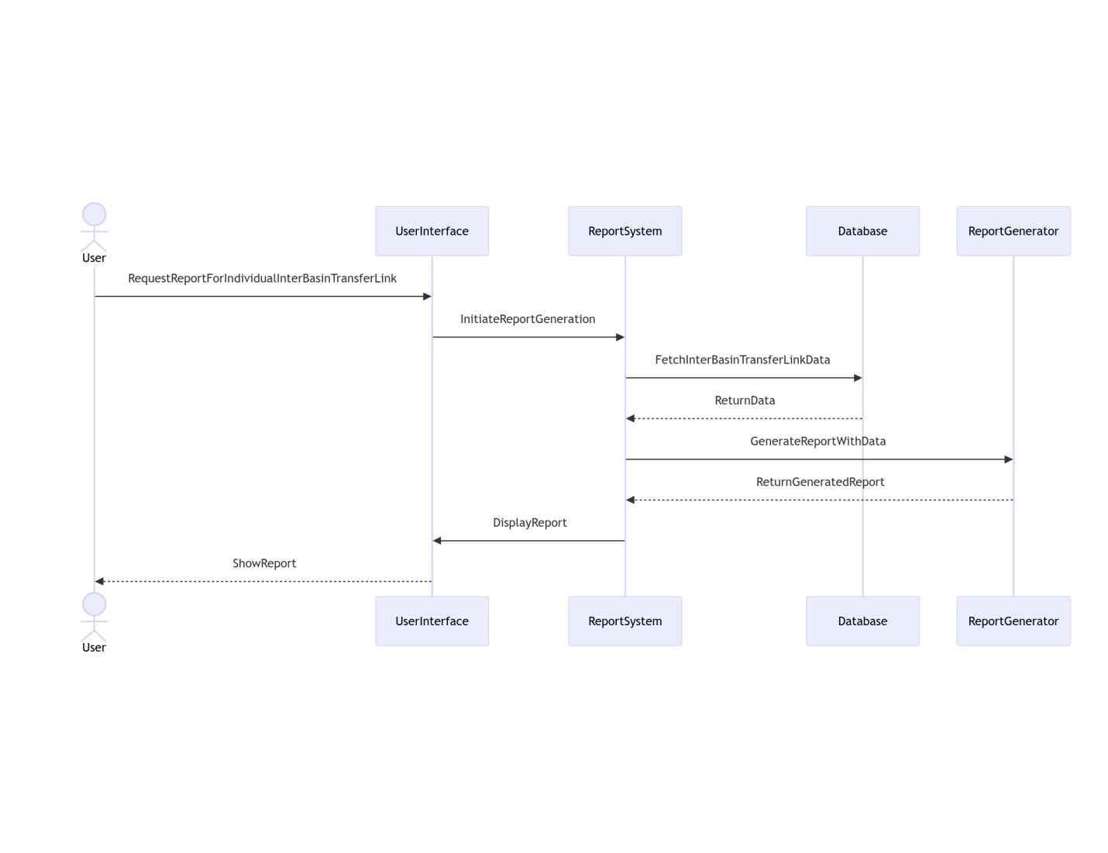

**Code_for_Figure_006_Visualization_Sequence_Notgpt:-**

@startuml

actor User

participant "Report System" as ReportSystem

participant "Database" as Database

participant "Report Generator" as ReportGenerator

participant "User Interface" as UserInterface

User -> UserInterface: Request Report for Individual Inter Basin Transfer Link

User Interface -> ReportSystem: Initiate Report Generation

ReportSystem -> Database: Fetch Inter Basin Transfer Link Data

Database --> ReportSystem: Return Data

ReportSystem -> ReportGenerator: Generate Report with Data

ReportGenerator --> ReportSystem: Return Generated Report

ReportSystem -> UserInterface: Display Report

User Interface --> User: Show Report

@enduml

**Table- 1: Salient Features of Damanganga Pinjal Link**

|  |  |  |  |  |  |
| --- | --- | --- | --- | --- | --- |
| **1** | **Location** | **Maharashtra and Gujarat** | | | |
| **2** | **Components of Project** | | | | |
| i) | Dam / Reservoir/Barrage | Dams (03 Nos) | | | |
| a) River | Damanganga/Vagh; Vaitarna/Pinjal | | | |
| b) Location | Maharashtra | | Gujarat | |
| c) Submergence Area(ha) | Bhugad Dam | | Khargihill Dam | |
| 1903 | | 1558 | |
| d) Forest land(ha) | Bhugad Reservoir | | Khargihill Reservoir | |
| 290 | | 676 | |
| e) Culturable Land(ha) & (Private land) | 810 | | 612 | |
| f) private land(ha)@startuml  actor User  participant "Data Collection System" as DCS  participant "Analysis System" as AS  participant "Visualization System" as VS  User -> DCS: Request surface profile data  activate DCS  DCS -> DCS: Collect elevation data  DCS -> AS: Send collected data  deactivate DCS  activate AS  AS -> AS: Analyze data  AS -> VS: Generate surface profile  deactivate AS  activate VS  VS -> User: Display surface profile  deactivate VS  @enduml |  | |  | |
| g) Others land(ha) | 803 | | 270 | |
| h) Population affected (Nos) | 20,501 | | 19273 | |
| i) Village affected partially (no.) Fully | Nil | | Nil | |
| Partially | 14 | | 16 | |
| ii) | Link Canal(RBC/LBC)/Tunnel | | | | |
| a) Length (km) | Tunnel Bhugad-Khargihill reservoir Length=17.488 km | Tunnel connecting-Kharghill-Pinjal reservoir  Length=25.244 km | | |
| b) Location (Passing through: districts) | Bhugad Dam | Kharghill Dam | | |
|  | Thane District | Nasik District | | |
| **3** | **Diversion Quantity(MCM)** | **Bhugad Dam** | **Kharghill Dam** | | **Pinjal Dam** |
|  |  | 210 | 369 | | 316 |
|  |  | Total 895(MCM) | | | |
| **4** | **Benefits From Project** | | | | |
| i) | Irrigation Benefits (ha) | Nil | | | |
| ii) | Hydropower Generation (MU) | Maharashtra | | Gujarat | |
| 16.20 MU | | 9.09 MU | |
| iii) | Power House (MW) | Bhugad Dam | | Kharghill Dam | |
| 2MW | | 3MW | |
| Total | | 5MW(25.29 MU) | |
| iv) | Domestic Water Supply (MCM) | 895 | | | |
| **5** | **States Benefitted** | **Gujarat, Maharashtra** | | | |
| **6** | **Employement Generation (No.)** | The Project affected households and also to each of the major son of such households, besides provision of subsistence allowance,annuity, mandatory employment for one member from each family. | | | |
| **7** | **Total Cost of Project** | (Rupees in Crores) | | | |
| i) | As per DPR(Price Level) | 3008.49 | | | |
| ii) | Projected to Year(2017-18) 5% escalation per annum | 3656.84 | | | |
| **8** | **Annual Cost of the Project** | **(Rupees in Crores)** | | | |
| i) | As per DPR(Price Level) | 407.58 | | | |
| ii) | Projected to Year(2017-18) 5% escalation per annum | 525.79 | | | |
| **9** | **Annual Benefits(in Crores)** | | | | |
| i) | As per DPR(Price Level) | 732.21 | | | |
| ii) | Projected to Year(2017-18) 5% escalation per annum | 890.01 | | | |
| **10** | **Economic Aspect** | | | | |
| i) | Benefit Cost Ratio (BCR) | 1.8 | | | |
| ii) | Internal Rate of Return(IRR) (%) | 14.95 | | | |
| **11** | **Construction Period** | **7 Years** | | | |
| **Source: National Water Development Agency** | | | | | |

**Diagram_Figure_006_Visualization_ClassDiagram_PlantUml:-**

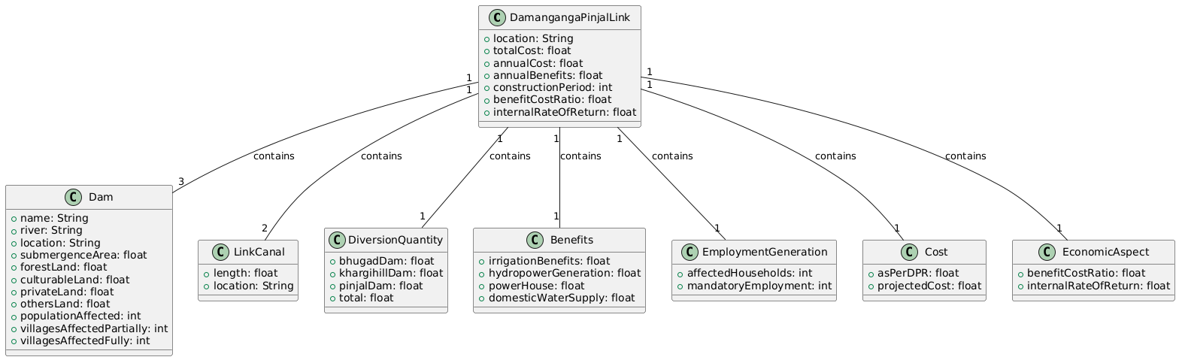

**Code_for_Figure_006_Visualization_ClassDiagram_PlantUml:-**

@startuml

class DamangangaPinjalLink {

+location: String

+totalCost: float

+annualCost: float

+annualBenefits: float

+constructionPeriod: int

+benefitCostRatio: float

+internalRateOfReturn: float

}

class Dam {

+name: String

+river: String

+location: String

+submergenceArea: float

+forestLand: float

+culturableLand: float

+privateLand: float

+othersLand: float

+populationAffected: int

+villagesAffectedPartially: int

+villagesAffectedFully: int

}

class LinkCanal {

+length: float

+location: String

}

class DiversionQuantity {

+bhugadDam: float

+khargihillDam: float

+pinjalDam: float

+total: float

}

class Benefits {

+irrigationBenefits: float

+hydropowerGeneration: float

+powerHouse: float

+domesticWaterSupply: float

}

class EmploymentGeneration {

+affectedHouseholds: int

+mandatoryEmployment: int

}

class Cost {

+asPerDPR: float

+projectedCost: float

}

class EconomicAspect {

+benefitCostRatio: float

+internalRateOfReturn: float

}

DamangangaPinjalLink "1" -- "3" Dam : contains

DamangangaPinjalLink "1" -- "2" LinkCanal : contains

DamangangaPinjalLink "1" -- "1" DiversionQuantity : contains

DamangangaPinjalLink "1" -- "1" Benefits : contains

DamangangaPinjalLink "1" -- "1" EmploymentGeneration : contains

DamangangaPinjalLink "1" -- "1" Cost : contains

DamangangaPinjalLink "1" -- "1" EconomicAspect : contains

@enduml

**4. Surface profile for Peninsular components of the proposed Inter basin Transfer Link:**

**Fig 3: Elevation/ surface profile of the Damanganga Pinjal Link (Peninsular component)**

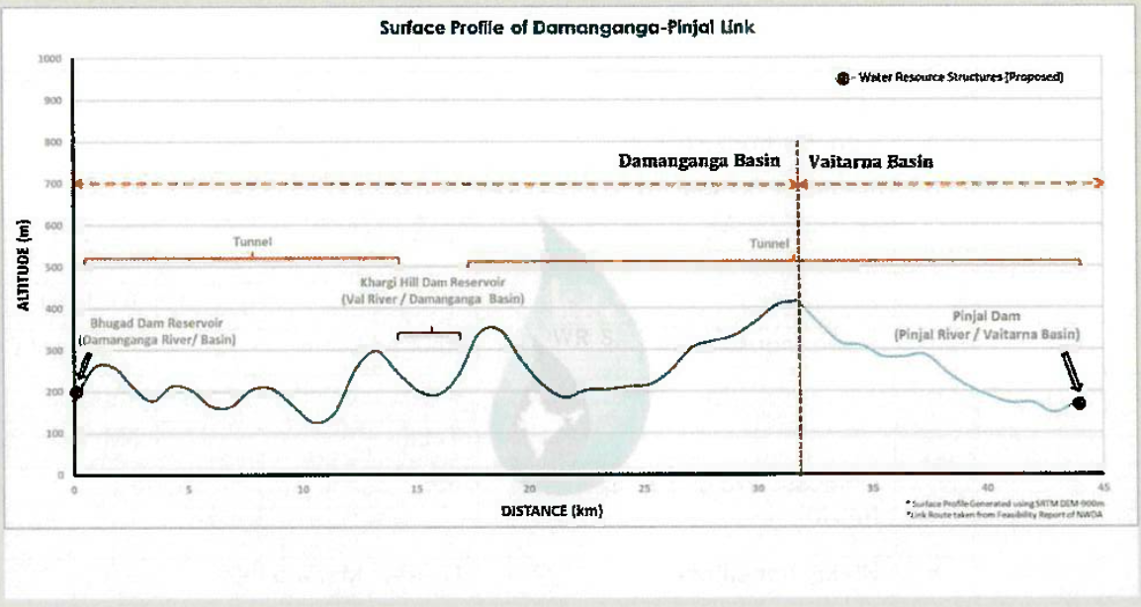

**Diagram_Figure_006_ Visualization_Sequence_PlantUML:-**

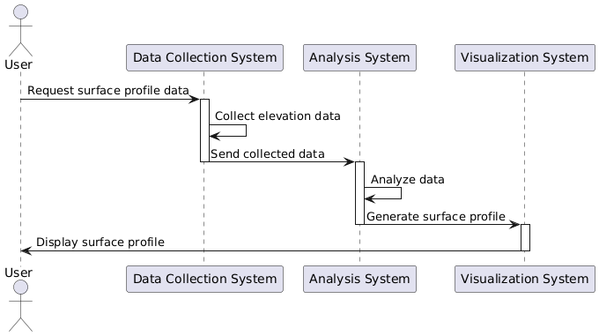

**Code_for_Figure_006_Visualization_Sequence_PlantUML:-**

@startuml

actor User

participant "Data Collection System" as DCS

participant "Analysis System" as AS

participant "Visualization System" as VS

User -> DCS: Request surface profile data

activate DCS

DCS -> DCS: Collect elevation data

DCS -> AS: Send collected data

deactivate DCS

activate AS

AS -> AS: Analyze data

AS -> VS: Generate surface profile

deactivate AS

activate VS

VS -> User: Display surface profile

deactivate VS

@enduml

**5. Executive summary of Individual Inter basin Transfer Link :** Executive summary of all the 30 components with compiled information i.e, structures, cost and other information are provided.

**Diagram_Figure_006_ Visualization_Sequence_PlantUML:-**

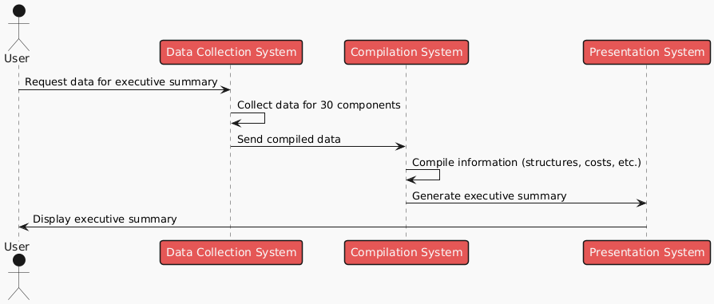

**Code_for_Figure_006_Visualization_Sequence_PlantUML:-**

@startuml

!theme mars

actor User

participant "Data Collection System" as DCS

participant "@startuml

!theme mars

actor User

participant "Data Collection System" as DCS

participant "Compilation System" as CS

participant "Presentation System" as PS

User -> DCS: Request data for executive summary

DCS -> DCS: Collect data for 30 components

DCS -> CS: Send compiled data

CS -> CS: Compile information (structures, costs, etc.)

CS -> PS: Generate executive summary

PS -> User: Display executive summary

@endumlCompilation System" as CS

participant "Presentation System" as PS

User -> DCS: Request data for executive summary

DCS -> DCS: Collect data for 30 @startuml

actor User

participant "National Water Development Agency" as NWDA

participant "Scanning System" as SS

participant "Digitization System" as DS

participant "Data Harmonization System" as DHS

participant "Map Preparation System" as MPS

participant "GIS Hosting System" as GHS

== Step 1: Data Scanning ==

User -> NWDA: Request data for 16 peninsular components

NWDA -> User: Provide hard copy data

User -> SS: Scan hard copy data

SS -> SS: Convert hard copy to digital format

== Step 2: Data Digitization ==

User -> DS: Initiate digitization of components

DS -> DS: Digitize structures (name, type, status, link)

DS -> DS: Digitize reservoirs (name, status, link)

DS -> DS: Digitize links (link name, details)

DS -> DS: Digitize inter-basin transfer links (all 30 links)

== Step 3: Topology Correction and Data Harmonization ==

User -> DHS: Initiate topology correction

DHS -> DHS: Perform topology correction

DHS -> DHS: Harmonize data

DHS -> DHS: Validate data

== Step 4: Map Preparation ==

User -> MPS: Request preparation of map document

MPS -> MPS: Prepare map with layers (basin, sub-basin, rivers)

MPS -> MPS: Add labels, legends, scale

MPS -> GHS: Send map document for hosting

== Step 5: Hosting GIS Layers and Reports ==

GHS -> GHS: Host GIS layers and reports

GHS -> User: Provide access to reports/maps (surface profile, salient features, etc.)

@endumlcomponents

DCS -> CS: Send compiled data

CS -> CS: Compile information (structures, costs, etc.)

CS -> PS: Generate executive summary

PS -> User: Display executive summary

@enduml

**Frequency of Up-dation:-**As per data made available by National Water Development Agency.

**Measure of Success:-** Inter-Basin Transfer Links offers information of the various components of the water transfer links (source: NWDA). In India, rainfall distribution is highly variable both temporally and spatially. Inter basin transfer link proposes river water transfer from the region of surplus to deficit areas. This may provide an effective ways to enhance irrigation potential, to mitigate floods and droughts and reduce regional imbalance by way of additional irrigation, domestic and industrial water supply, hydropower generation, navigational facilities etc.

**Input Data Required:-**

**Data Points:**

|  |  |  |
| --- | --- | --- |
| **Data point** | **Data Type** | **Agency** |
| Administrative Boundary | Polygon | NWIC |
| River Layer | Line | NWIC |
| Major Rivers | Polygon | NWIC |
| Inter basin Transfer links (all 30 links) | Line | NWDA |
| Link ALL (16 Peninsular link in detail) | Line | NWDA |
| Reserv@startuml  !theme mars  actor User  participant "Data Collection System" as DCS  participant "Compilation System" as CS  participant "Presentation System" as PS  User -> DCS: Request data for executive summary  DCS -> DCS: Collect data for 30 components  DCS -> CS: Send compiled data  CS -> CS: Compile information (structures, costs, etc.)  CS -> PS: Generate executive summary  PS -> User: Display executive summary  @endumloir/ waterbody (associated with IBTL) | Polygon | IWAI/NWDA |
| Structures (Dam/BWA/Lifts) | Point | IWAI/NWDA |

**Process:**

**Algorithm/Tools:-**

National Water Development Agency has provided the detailed data for 16 peninsular components of the Inter Basin Transfer links. The integration of the data from NWDA to ht Inter-Basin Transfer Links module will require following steps.

**Step 1:**Data received from NWDA in hard copy format is first scanned so that further digitization of various datasets can be performed.

**Step 2:**Digitization of components of Inter Basin Transfer links such as —

* **Structures:** name of the structure, type i.e. dam/BWA etc, status i.e. proposed/existing), associated Link name.
* **Reservoir/Waterbody (associated with IBTL):** Name of the Reservoir/waterbody linked with the proposed IBTL along with their status (proposed/ existing) & associated Link name.
* **Link All:** Link Name as well as the detail of each peninsular link i.e. tunnel/ Canal part etc.
* **Inter basin Transfer links:** Containing all the 30 links

**Step 3:**Topology Correction and data harmonization of digitized data.

**Step 4:**Preparation of map document of Inter Basin Transfer Links data layers along with relevant hydrological layers i.e. Basin, sub basin, major rivers, with label, legends, scale and suitable visibility of layers at varying scales.

**Step 5:**Hosting GIS layers and reports in the Inter-Basin Transfer Links Module. A draft GUI of the IBTL module (from the Inter-Basin Transfer Links module of India-WRIS) can be shown below.

**Diagram_Figure_007 Algorithm_Sequence_PlantUML:-**

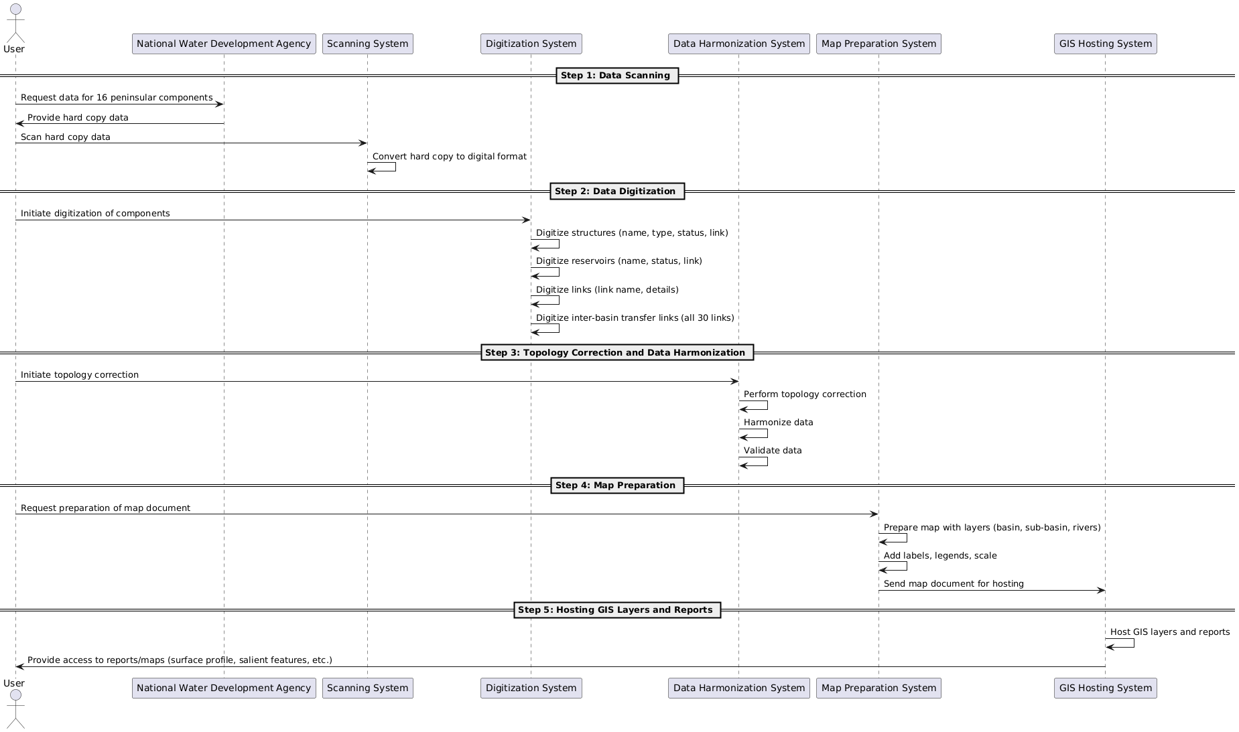

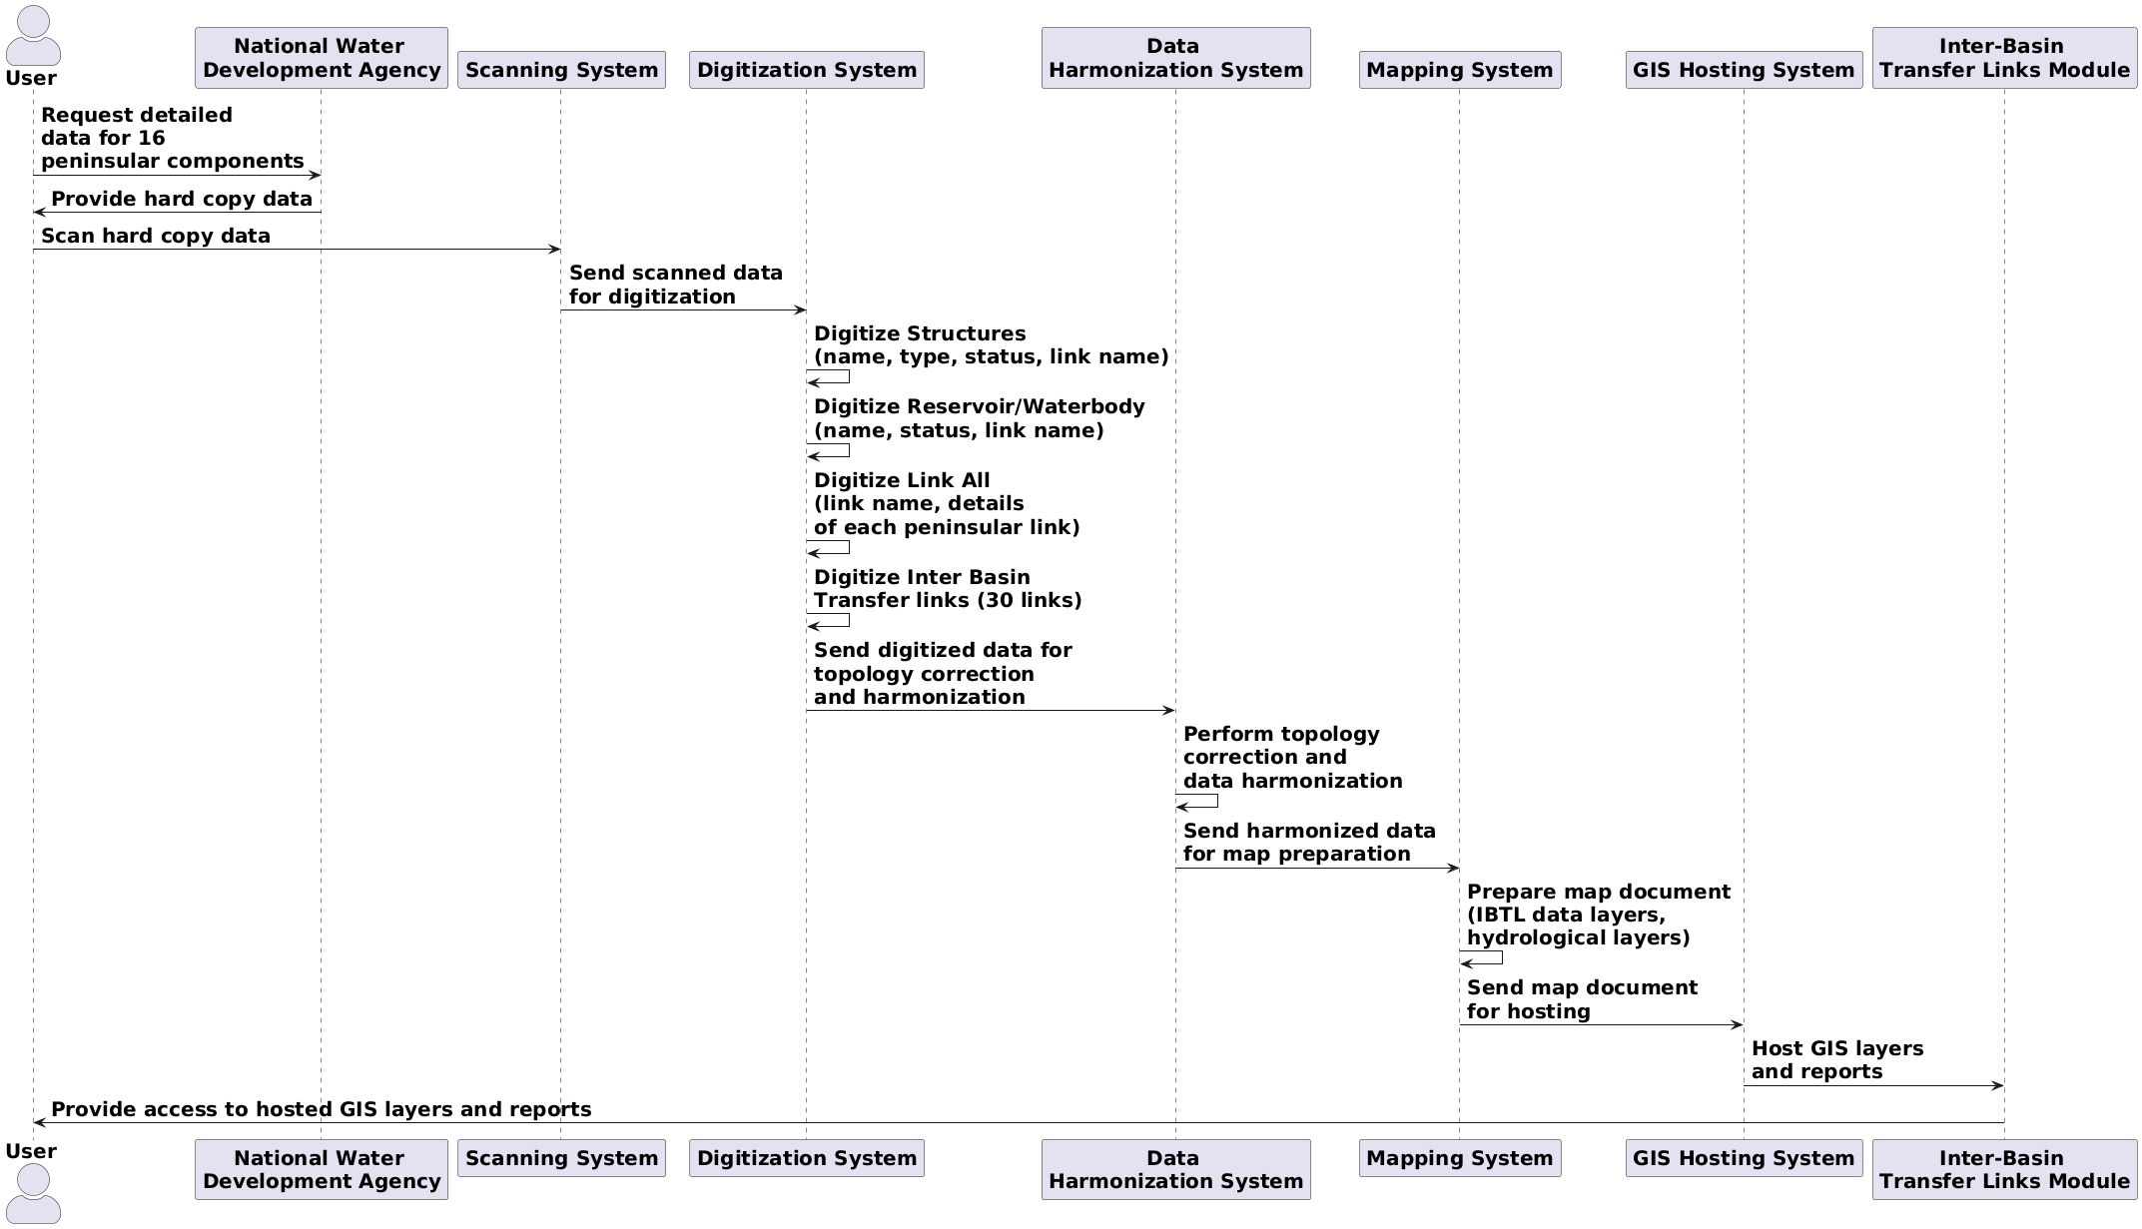

**Code for_Figure_007 Algorithm_Sequence_PlantUML:-**

@startuml

skinparam actorstyle awesome

skinparam defaultfontsize 20

actor "**User**" as User

participant "**National Water** \n**Development Agency**" as NWDA

participant "**Scanning System**" as Scanner

participant "**Digitization System**" as Digitizer

participant "**Data** \n**Harmonization System**" as Harmonizer

participant "**Mapping System**" as Mapper

participant "**GIS Hosting System**" as GISHost

participant "**Inter-Basin** \n**Transfer Links Module**" as IBTLModule

User -> NWDA: **Request detailed** \n**data for 16** \n**peninsular components**

NWDA -> User: **Provide hard copy data**

User -> Scanner: **Scan hard copy data**

Scanner -> Digitizer: **Send scanned data** \n**for digitization**

Digitizer -> Digitizer: **Digitize Structures** \n**(name, type, status, link name)**

Digitizer -> Digitizer: **Digitize Reservoir/Waterbody** \n**(name, status, link name)**

Digitizer -> Digitizer: **Digitize Link All** \n**(link name, details** \n**of each peninsular link)**

Digitizer -> Digitizer: **Digitize Inter Basin** \n**Transfer links (30 links)**

Digitizer -> Harmonizer: **Send digitized data for** \n**topology correction** \n**and harmonization**

Harmonizer -> Harmonizer: **Perform topology** \n**correction and** \n**data harmonization**

Harmonizer -> Mapper: **Send harmonized data** \n**for map preparation**

Mapper -> Mapper: **Prepare map document** \n**(IBTL data layers,** \n**hydrological layers)**

Mapper -> GISHost: **Send map document** \n**for hosting**

GISHost -> IBTLModule: **Host GIS layers** \n**and reports**

IBTLModule -> User: **Provide access to hosted GIS layers and reports**

@enduml

**Data Validation:-**Digitization of components of inter basin transfer links from hard copy maps/ survey sheets/toposheets format requires geospatial as well as attribute validation time to time.

**Software Technologies:-** QGIS Desktop, QGIS Enterprise

**Dependencies & Risks:**Error during data preparation (hardcopy to GIS data creation) i.e. RMSE error, Interpretational erros etc. impacts quality of the processed data. Requirement of data updation based upon the current status (DPR study/ under construction) and data validation by the concerning government agency.

**User Acceptance Testing (UAT):-** NWIC

**Development Responsibility:** NWIC

**References :-**

**1**<https://indiawris.gov.in/wris/#/interbasintransferLink>

2 [www.nwda.gov.in](http://www.nwda.gov.in/)

**---End of Document---**